Converse Azure Days

Azure Infrastructure Orchestration and Automation

Windows Workshop Guide

August 1st, 2018

© 2018 Microsoft Corporation. All rights reserved. This document is confidential and proprietary to Microsoft. Internal use only. This document is for informational purposes only. MICROSOFT MAKES NO WARRANTIES, EXPRESS OR IMPLIED, IN THIS SUMMARY.

This document is provided "as-is." Information and views expressed in this document, including URL and other Internet Web site references, may change without notice. You bear the risk of using it.

Some examples are for illustration only and are fictitious. No real association is intended or inferred.

# Azure Infrastructure and Automation - Windows Workshop Guide

## Overview

This workshop guide is intended to walk you through the automated deployment of a Windows Server 2016 environment running an IIS website. We will be using Powershell, Azure Resource Manager (ARM) templates, and Powershell DSC to deploy and configure the environment. We will also look at then packaging the deployed app environment as a Docker image, pushing the image to an Azure Container Registry, and then deploying the image as an Azure Container Instance.

## What You Will Build

A simple application deployment on IaaS infrastructure consisting of:

Virtual Networks

Load Balancer

Operations Management Suite

Azure Automation

KeyVault

Virtual Machines

DSC configuration for IIS

Windows containers using Dockerfile (optional)

## Requirements

* Powershell ISE
* Git Bash
* Code Editor (Visual Studio Code recommended)
* Text Editor (such as notepad or textedit)
* Azure Powershell SDK cmdlets
* Azure Subscription with Owner role (provided for workshop)

## Help References

|  |  |
| --- | --- |
| Powershell ISE overview | https://docs.microsoft.com/en-us/powershell/scripting/core-powershell/ise/introducing-the-windows-powershell-ise?view=powershell-5.1 |
| Git Installation | https://git-scm.com/book/en/v2/Getting-Started-Installing-Git |
| Visual Studio Code | https://code.visualstudio.com/ |
| Azure Powershell installation | https://docs.microsoft.com/en-us/powershell/azure/install-azurerm-ps |

# Step 1 – Clone GitHub Repository and Open Notepad/TextEdit

## Overview

The first step involves cloning a Github repository that includes the scripts and configuration files that will be used in this workshop.

## Detailed Steps

1. Open Git Bash, change to a directory in which you’d like to create the new repo directory to clone into

mkdir <directory name>

1. Change the working directory to your newly created one and then clone the repository from Github.

cd <directory name>

git clone https://github.com/mmcsa/BostonAzureDays.git

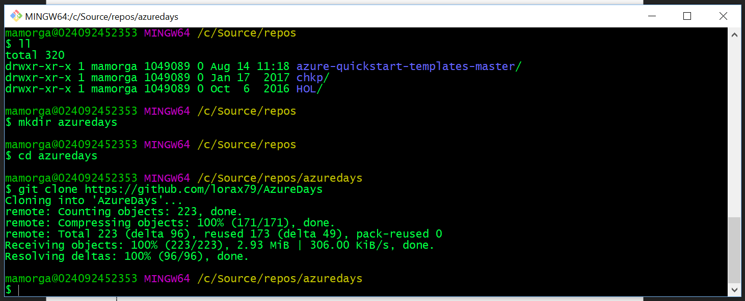

1. Open Notepad, TextEdit or another tool to keep track of IDs, names, and other items you use in various steps of the workshop.

# Step 2 – Open files in PS ISE & VS Code

## Overview

This step involves opening the directory we just cloned from github in Visual Studio Code.

## Detailed Steps

1. Open Visual Studio Code
2. CTRL + P will expose command window, type “ext install” ENTER to show available extensions.
3. Search for “azure resource manager” and install “Azure Resource Manager” tools (optional but useful for working with templates)

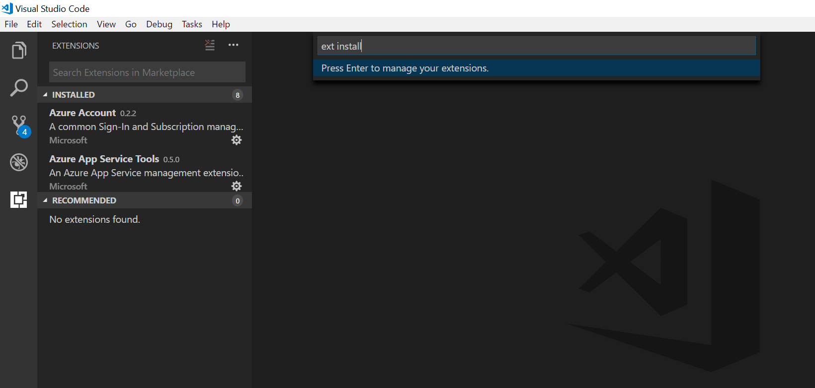

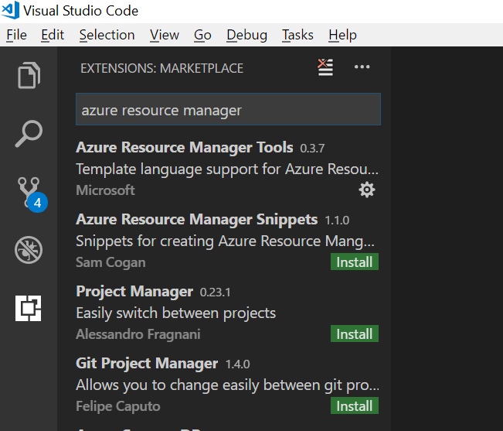

1. Select the Explorer icon and then “Open Folder”, browse to repo directory you just created and open.

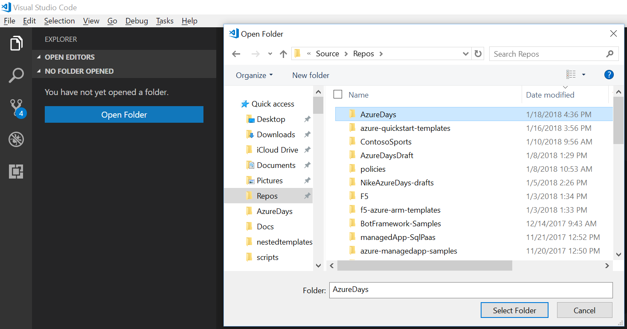

1. If you click the explorer icon in Visual Studio Code, you should see the contents of the directory.

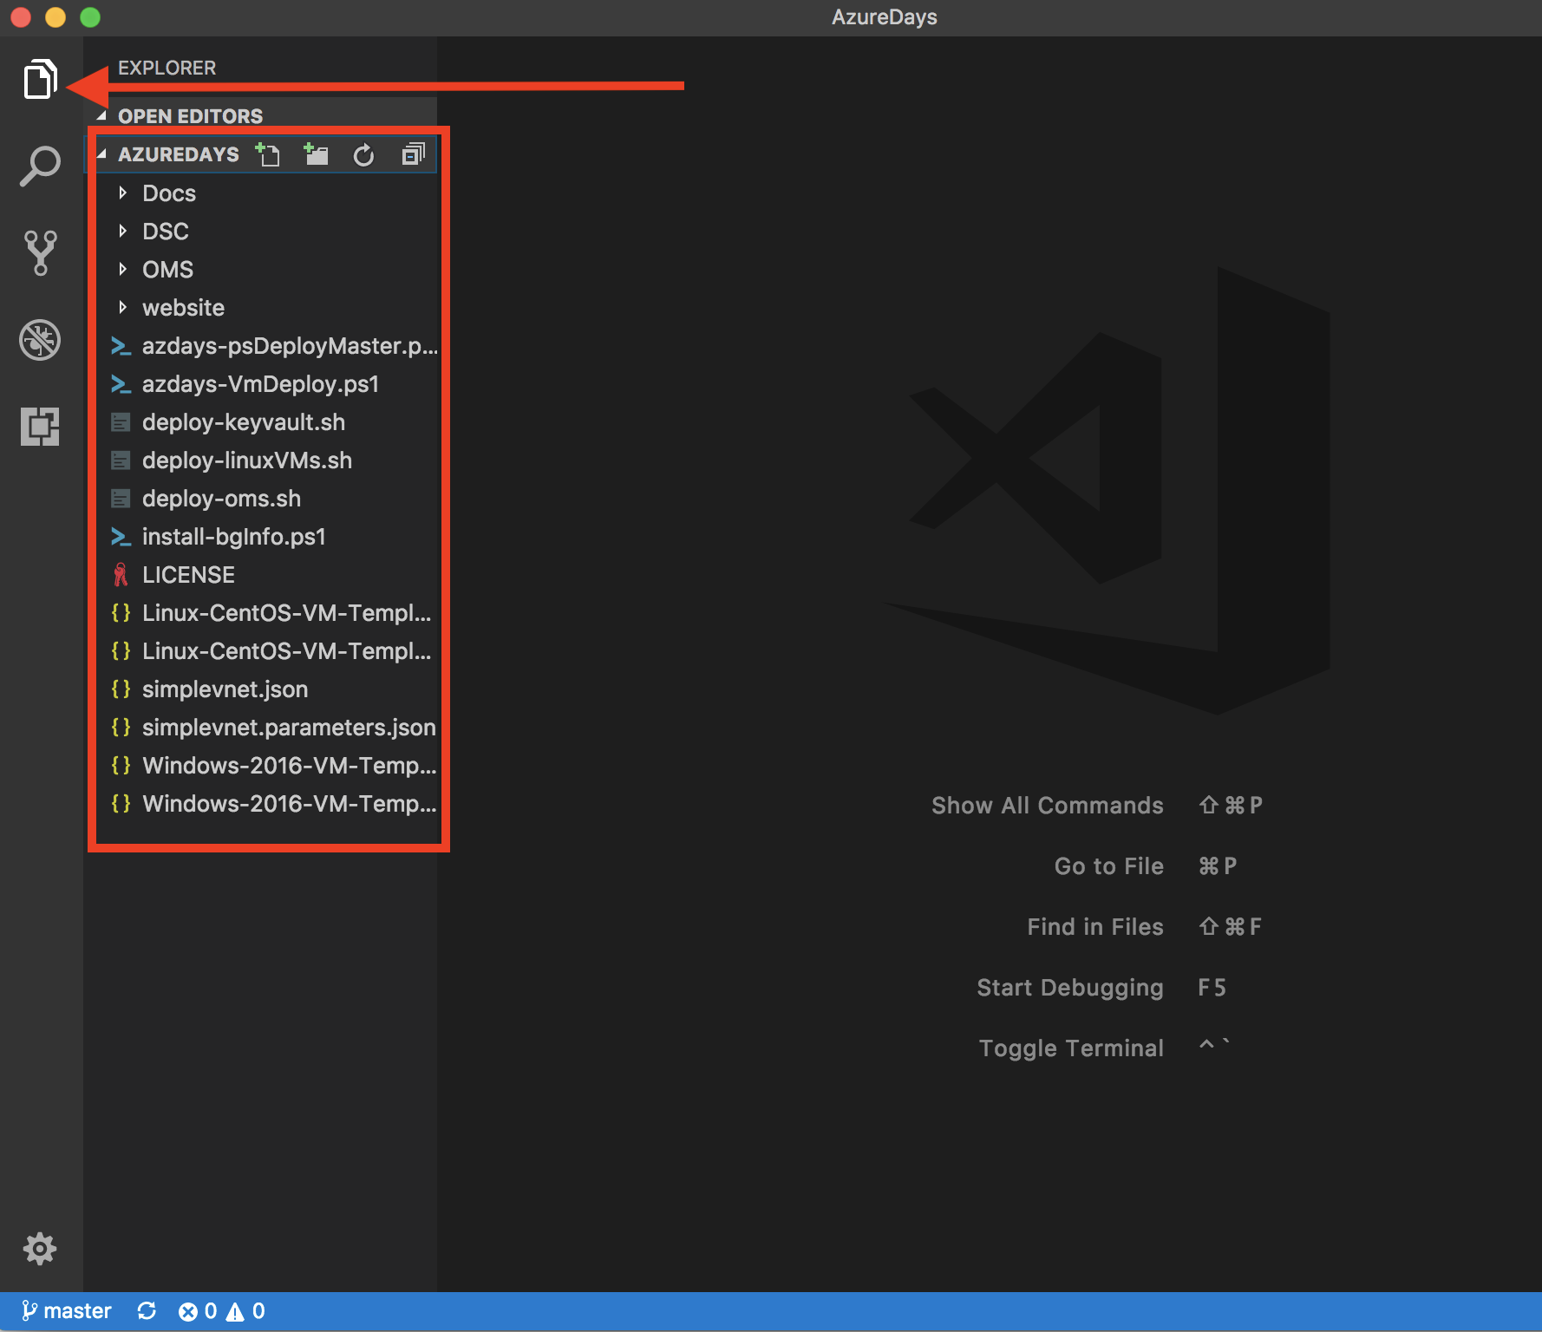

1. Open Powershell ISE, browse to your code directory and open the 3 - .ps1 files:   
   azdays-psDeployMaster, azdays-VmDeploy, and /DSC/WebConfig.
   1. azdays-psDeployMaster is a full step-by-step walkthrough of all the workshop steps. It is intended to expose you many of the cmdlets, objects, and patterns you can use with Powershell in Azure. Don’t just run the whole script end to end, you can select sections and run with F8 or the small ‘play’ button

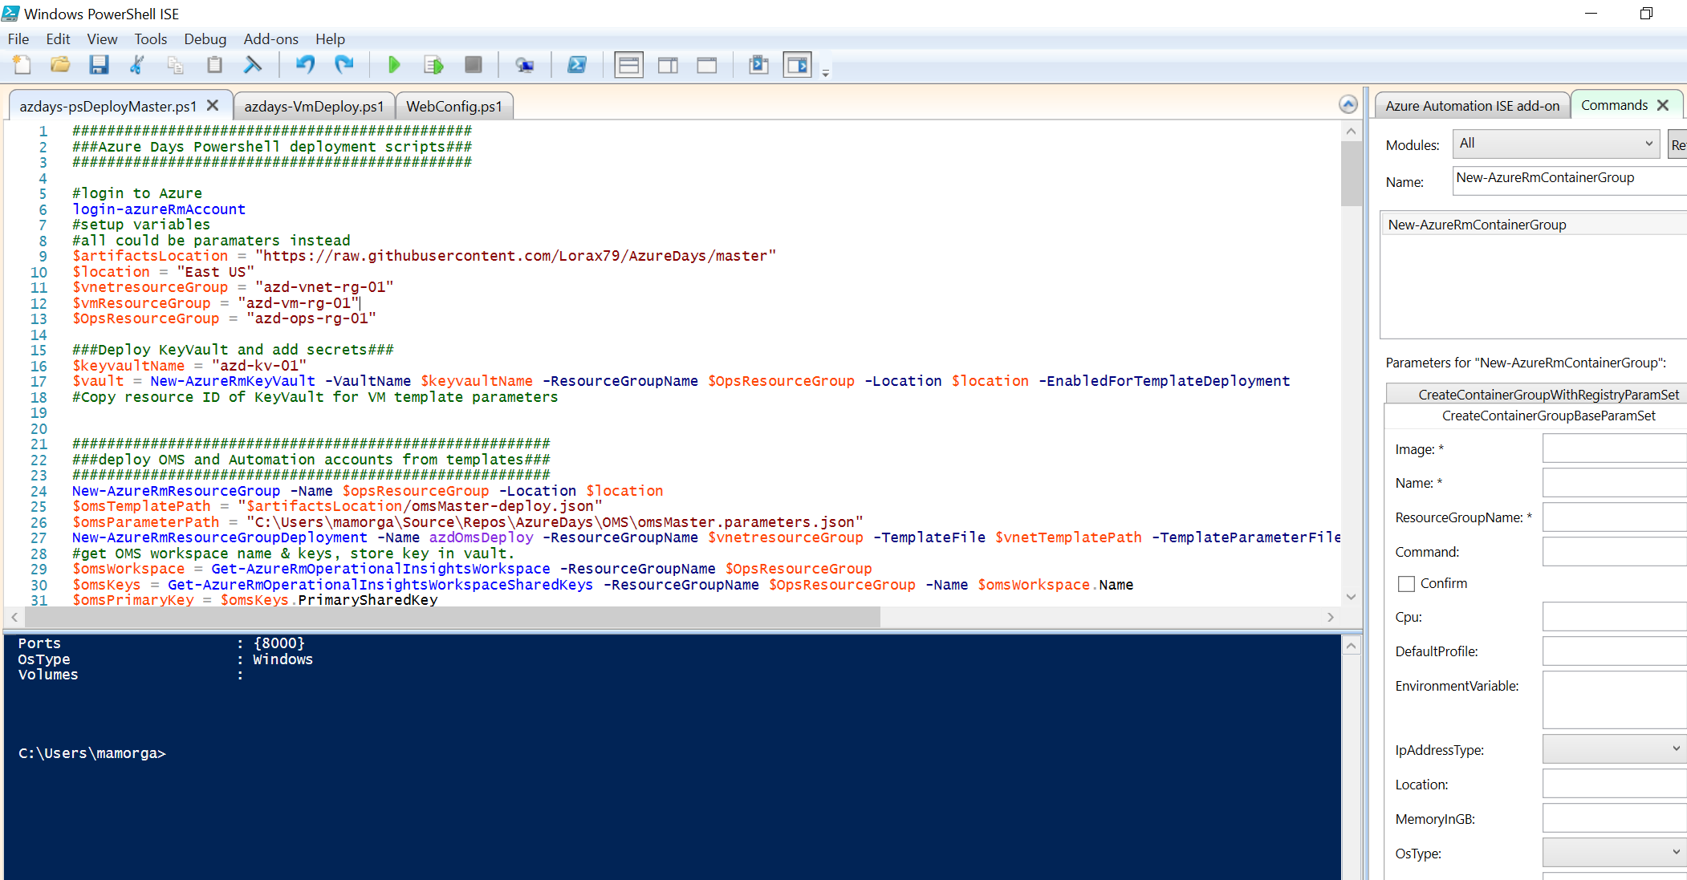

* 1. azdays-VmDeploy is intended to be run completely as a script/runbook with parameters when we get to the VM deployment steps.

# Step 3 – Login to Azure Portal and review Resource Groups

## Overview

To allow for a shorter workshop time length, the Resource Groups and operations resources for the workshop will be pre-deployed using an Azure Automation runbook. If you wish, you can view this runbook in the ‘azd-sharedops-rg-01’ resource group -> ‘azd-sharedops-aa-01’ automation account.

There will be 3 resource groups already deployed for each workshop attendee. This allows for fine control over access to resources through Role Based Access Control (RBAC)

* ‘azdbos-YOURNAME-ops-rg-01’ – Resource Group for Automation, Log Analytics, and KeyVault
* ‘azdbos-YOURNAME-vnet-rg-01’ – Resource Group for VNet and Load Balancer resources
* ‘azdbos-YOURNAME-vm-rg-01’ – Resource Group for Virtual Machines.

## Detailed Steps

1. Open a browser and go to <https://portal.azure.com> and login with your Nike AD credentials
2. In the resource browser on left side of page, select ‘Resource Groups’. Make sure the Subscription filter is set to show ‘az-training-01’.  
   You should see your pre-deployed resource groups listed.

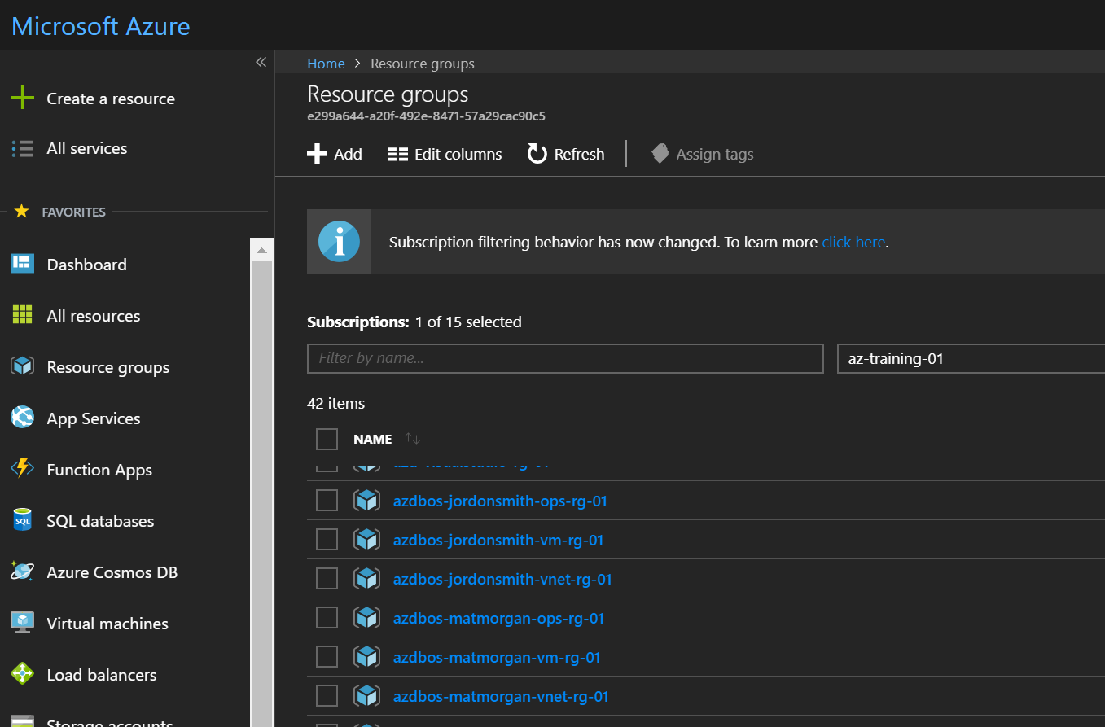

1. Select the Resource Group ‘azdbos-YOURNAME-ops-rg-01’ and explore the deployed resources in it.
   1. Storage Account – storage for application assets, can store blob/file/queue data.
   2. Automation Account – runbooks, variable / credential assets
   3. Log Analytics workspace – log & perf data monitoring & alerting
   4. Key Vault – HSM secured certificate / secret management
   5. Recovery Vault – Backup & Site Recovery management
   6. Solution packs for Log Analytics

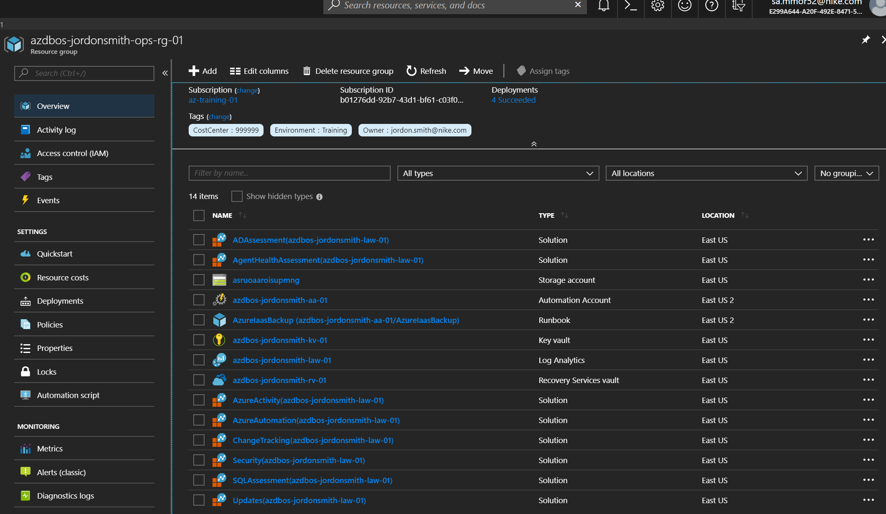

1. Click ‘Access control (IAM)’ and view the RBAC assignments for the Resource Group. Notice that your username is granted ‘Contributor’ role access at the Resource Group boundary. This role allows you to create/update/delete any resources in this RG, but not other Subscription resources. There are other access roles inherited from the Subscription. All users in the workshop are also granted ‘Reader’ role access to other Resource Groups.

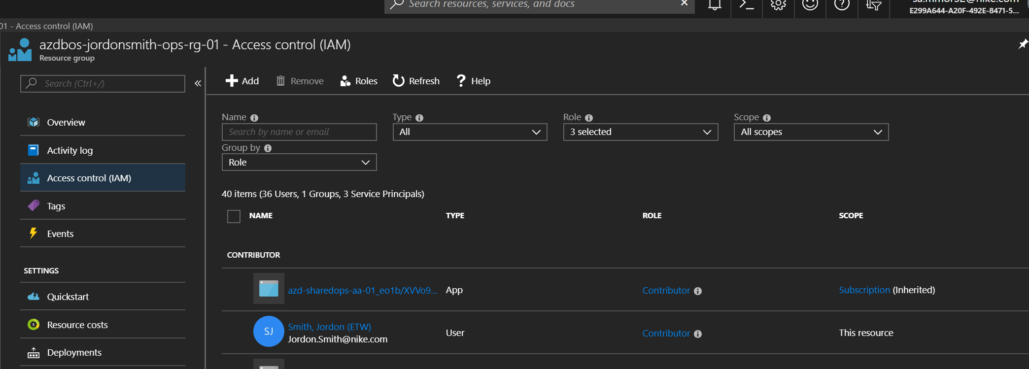

1. Browse to the network Resource Group ‘azdbos-YOURNAME-vnet-rg-01’. You should see 3 resources deployed: an Azure VNet, a Load Balancer, and a Public IP for the Load Balancer front-end.

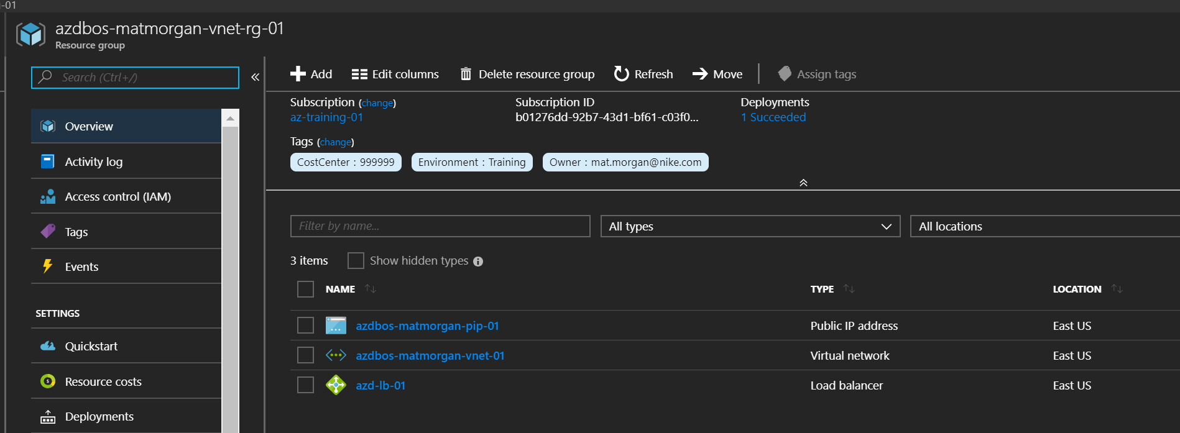

1. Browse to the Virtual Machine Resource Group ‘azdbos-YOURNAME-vm-rg-01’. There are no resources deployed there yet, we will add Virtual Machines in a future step.
2. The job will finish in a few minutes. When it completes, browse back to view Resource Groups and you will see 3 new groups created.

# Step 4 – Login to your subscription via Powershell ISE

## Overview

The Virtual Machines for this workshop will be deployed using a Powershell script. The Powershell ISE is a free extensible scripting environment included with Windows we will be using for the deployment. Alternately, we will show running the same script from the integrated CloudShell in the Azure Portal. Running Azure Resource Manager commands locally requires the Azure Powershell modules to be installed from <https://docs.microsoft.com/en-us/powershell/azure/install-azurerm-ps> if you haven’t already.

## Detailed Steps

1. In the ISE Command pane, type login-azureRmAccount
2. Login with the credentials for your Azure subscription.

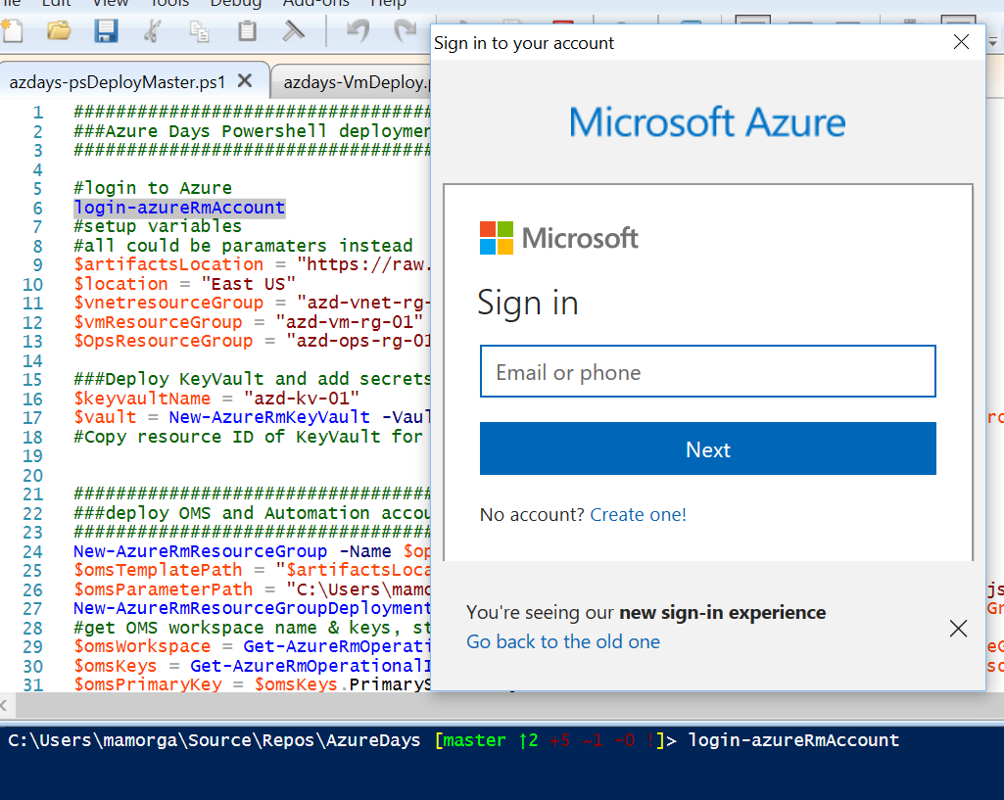

1. After login you will see your account, subscription, and tenant info. While we’re not using any of this info for the Windows automation it’s a good idea to copy it to a notepad.

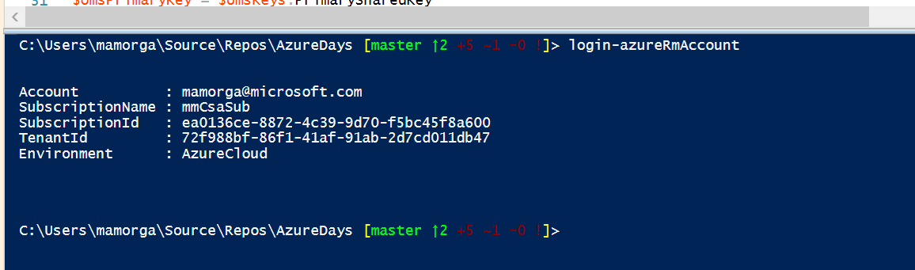

# Step 5 – Prepare DSC configuration and files for Website deployment

## Overview

We will be copying website content from the Git repo into our Azure Storage account. We will then be uploading and compiling a DSC (Desired State Configuration) template into the Automation account DSC service to make it available as a VM node config.

## Detailed Steps

1. Open the ‘/DSC/webConfig.ps1’ file in Powershell ISE. This is the DSC config we will be using to configure our Web VMs after deployment. It does the following:  
     
   Declares a config name (Webconfig) and imports modules it needs, sets variables for local directories and storage account access  
   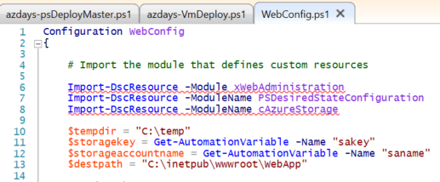  
     
   Declares a single Node name (‘Web’, which means machines using this config will have a nodeConfiguration name setting of ‘WebConfig.Web’), then installs .NET 4.5 and IIS Features needed.   
   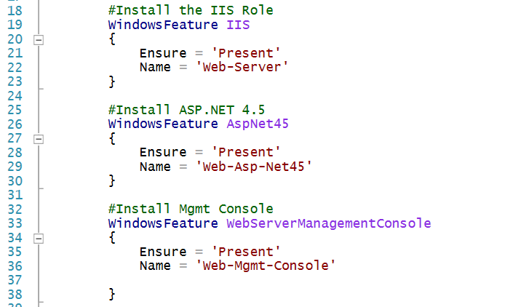

Finally, the config takes the steps needed to setup the website: Stops the default IIS site, checks for tempdir, copies the content from Storage to tempdir, Unzips the content into the IIS webroot, and creates the new site.   
  
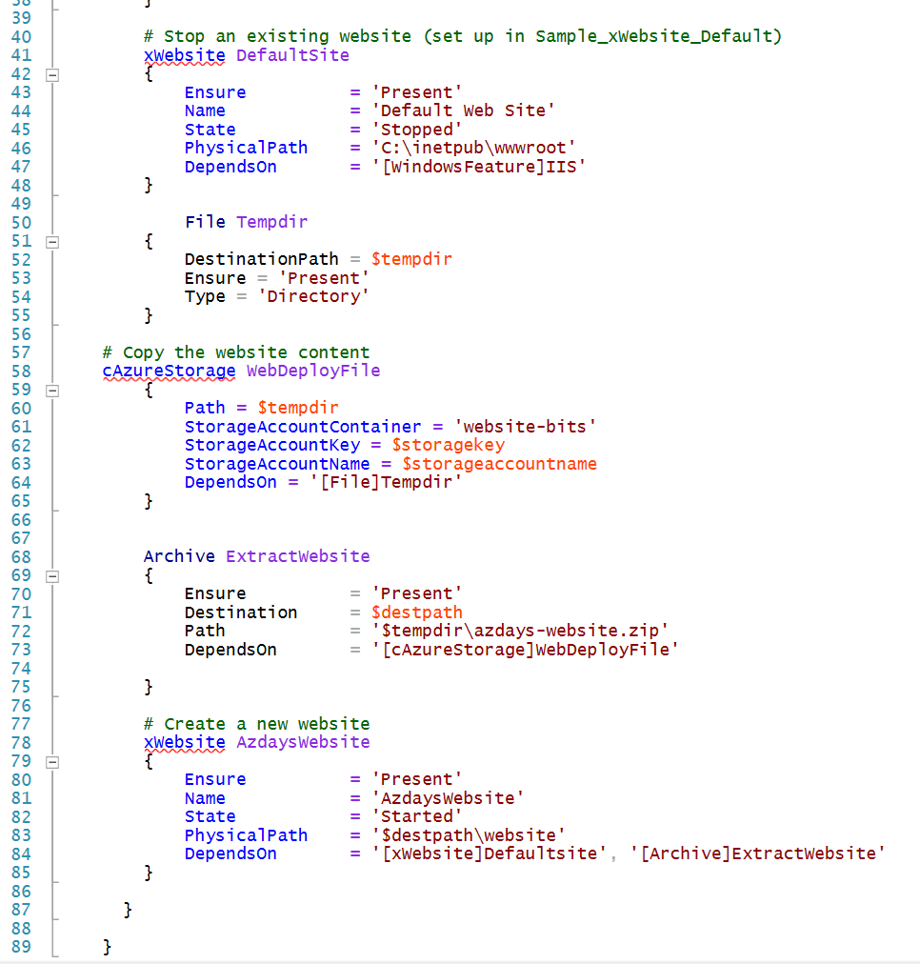

1. To upload and compile the configuration, browse to the your Automation account in the Azure portal and locate ‘<your-ops-resourceGroup> -> <your Automation Account> -> DSC Configurations’.

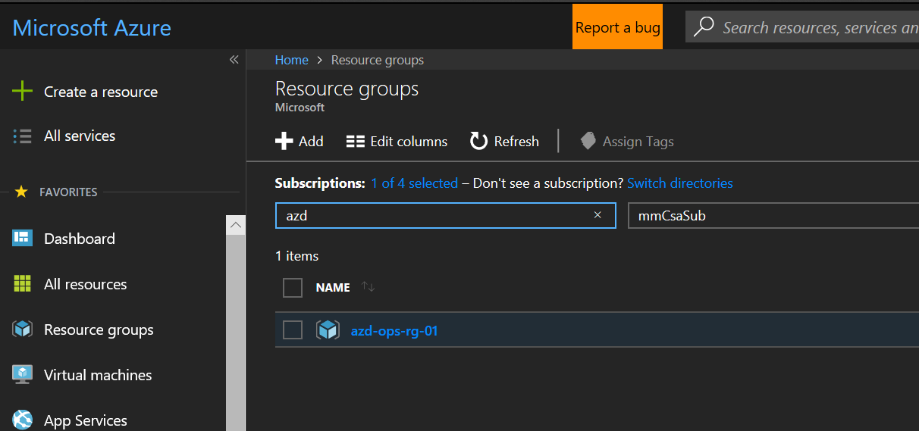

1. Select ‘Add a Configuration’, browse to the ‘WebConfig.ps1’ file and name it ‘WebConfig’ (default). Click OK.

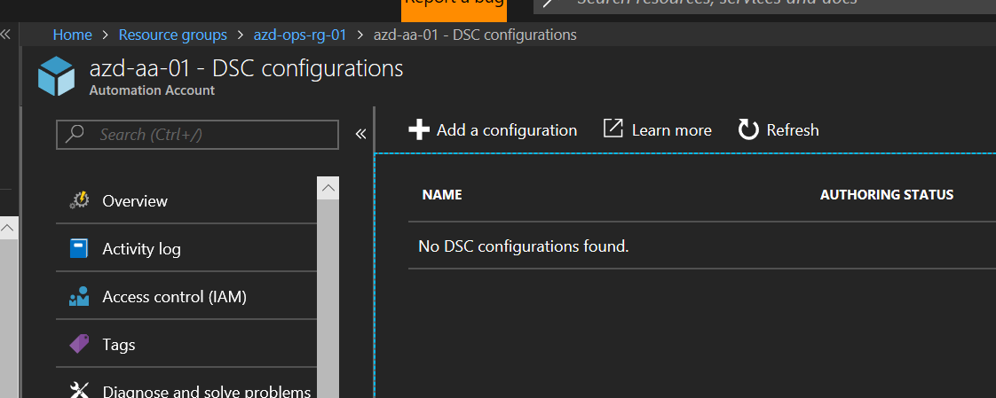  
  
  
  
  
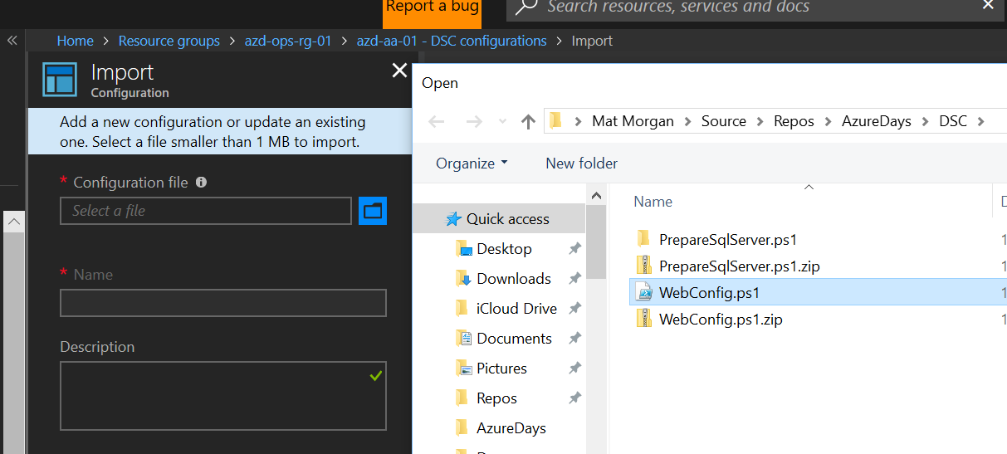

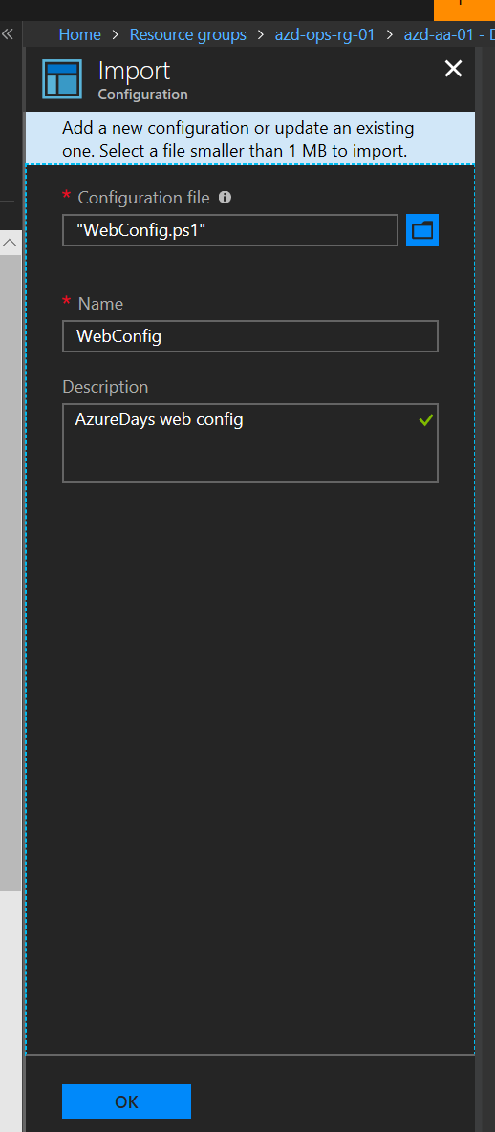

1. After config file is uploaded, select it and then click ‘Compile’. Click ‘Yes’ when asked to confirm. The compilation job should run for a few minutes & then show ‘Completed’ when done.

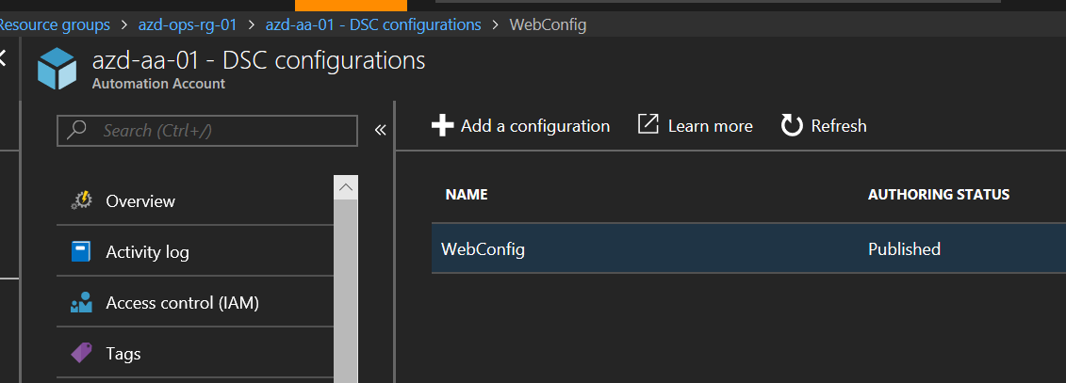  
  
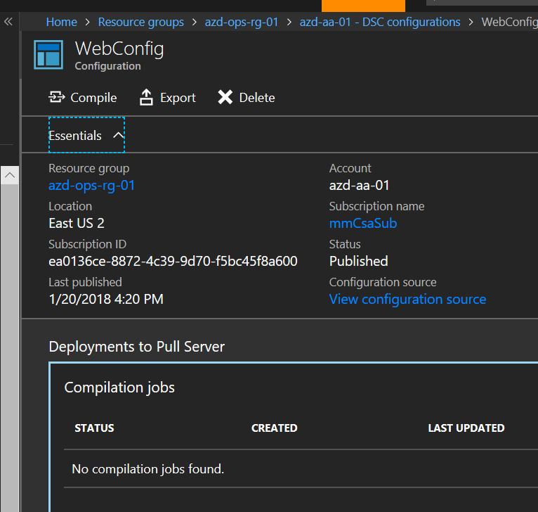  
  
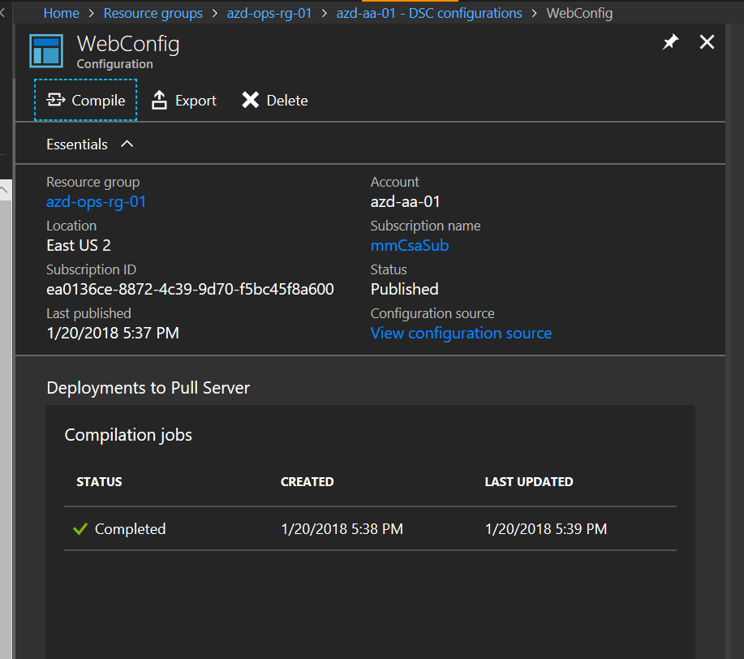

# Step 6 – Deploy Azure Virtual Machines

## Overview

We will be running a deployment script which will deploy from 1 – N identical VMs from an ARM template. The VMs are deployed into the ‘app’ subnet in your VNET (subnet 2) and are striped across update and fault domains in an Availability Set. After deploying the base VMs the template will add extensions to install/configure both the OMS agent (MMA extension) as well as DSC. The VMs will then pull their DSC Local Config Manager config from a repo, and then connect to your Automation account to find and pull their Node Configuration (webconfig.web). When complete you should have 2 identical Windows Server 2016 w Containers hosts running an IIS website.

## Detailed Steps

1. Open ‘azdays-boston- VmDeploy.ps1’ in Powershell ISE. We will be running directly from the ISE, however the same code should run called directly from PS, as an Automation runbook, or however as long as the required parameters are passed.   
   To run, press the ‘Run Script’ button or hit F5 from ISE. You can also navigate to the Repo directory in the command pane and type ‘.\azdays-boston-VMDeploy.ps1’.

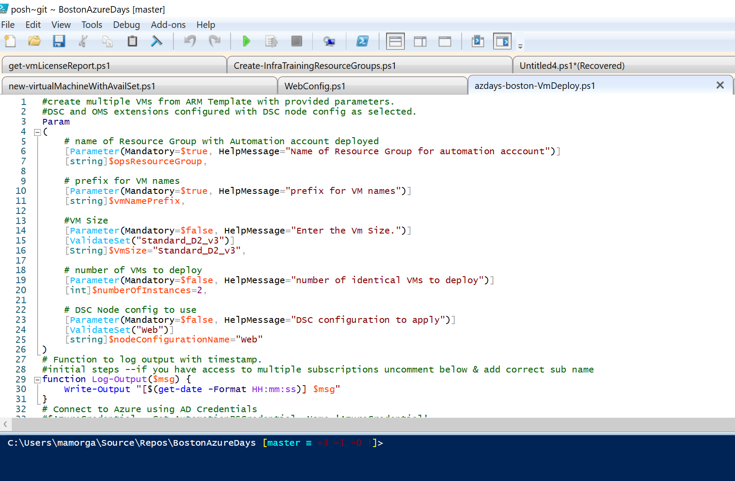

1. You will be prompted to enter 2 parameters when launching the script:  
     
   **opsResourceGroup** – enter the name of your ‘-ops-‘ resource group.   
   **vmNamePrefix** – enter an arbitrary naming prefix for your VMs – will append a digit based on VM # to the end.

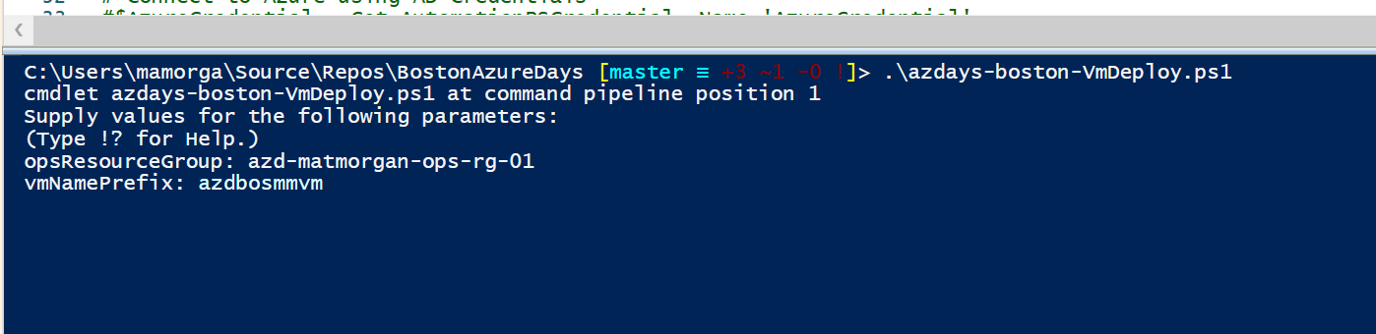

1. You will see verbose logging from the deployment while running. The VM deployment can take up to about 20 minutes to complete as the DSC configuration has a 15 minute pull interval between configurations. Once you reach the virtualMachine provisioning around 1 minute in without errors, you should expect the deployment to complete without issues.
2. If you cannot or don’t want to use the Powershell ISE to run the deployment, you can do so directly from the CloudShell in the Azure portal. Click the ‘Shell’ icon at the top-right of the portal window to launch CloudShell, and select Powershell from the shell selection dropdown.

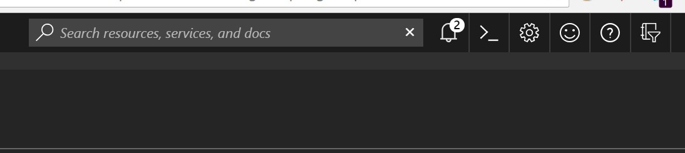

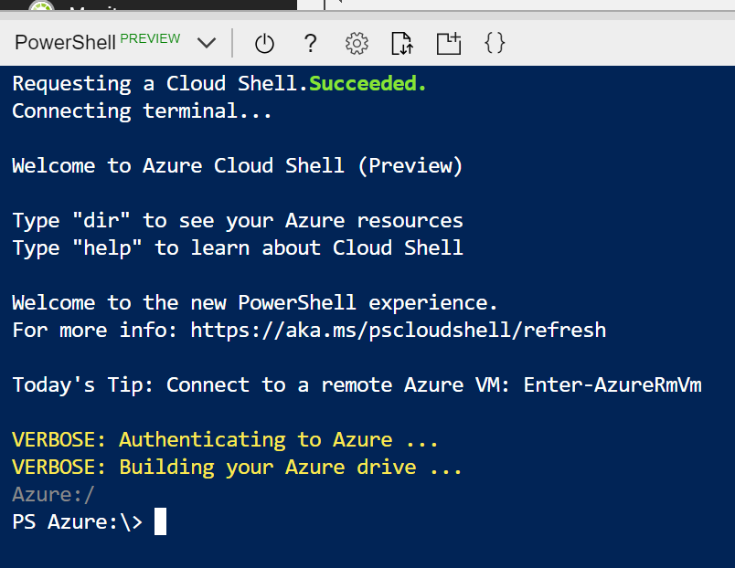

1. You can drag & drop the script file from Windows Explorer into CloudShell to save it in Azure storage. Files saved in the ‘/home/<username>/clouddrive’ directory will persist across CloudShell sessions. Type ‘cd /home’ and the ‘ls’ or ‘dir’ to verify your user path, then cd to clouddrive. Files that you drag & drop into the shell will be initially saved in your user root, so you will need to copy to /clouddrive (‘cd ..’ , ‘cp .\azdays-boston-VmDeploy.ps1 /clouddrive’). Verify by listing clouddrive after copying.

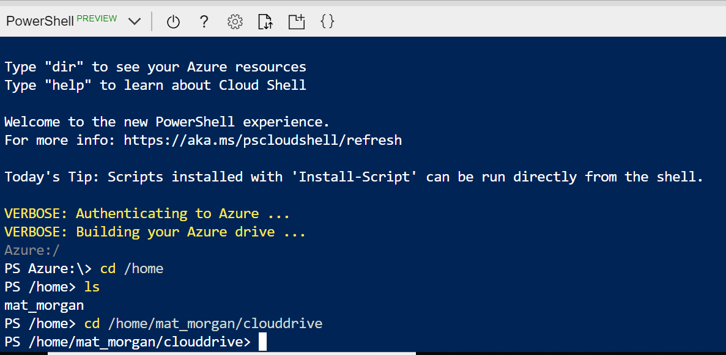

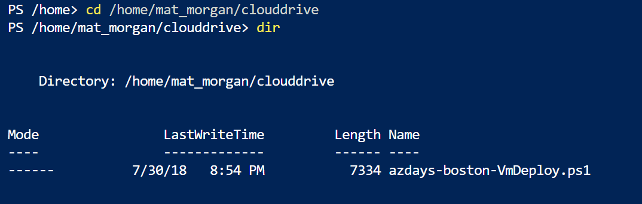

1. You can even edit with VSCode directly in CloudShell by clicking the code ‘{}’ icon and browsing to the file you wish to edit. CTRL + S will save the file. CTRL + Q to close the edit window.

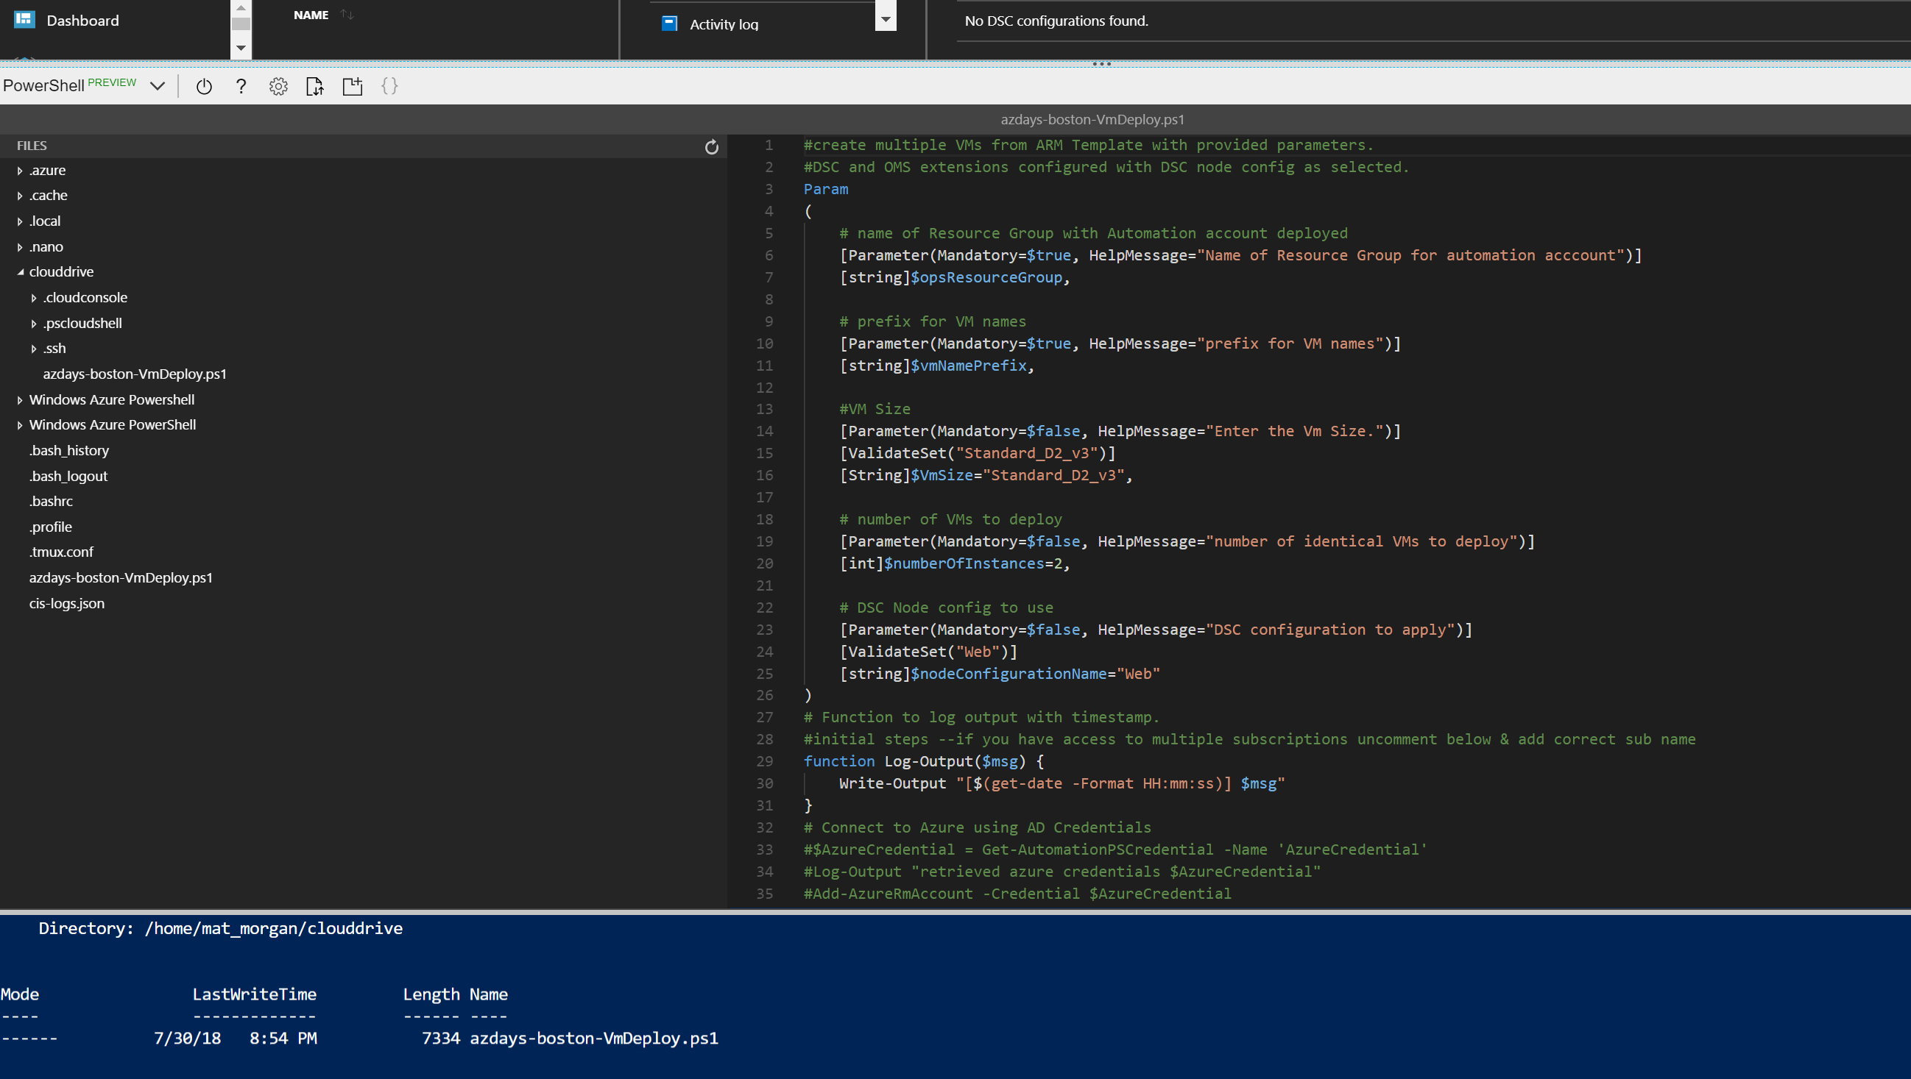

1. Run the deployment by typing ‘.\azdays-boston-Vmdeploy.ps1’ at the shell prompt and entering parameters.

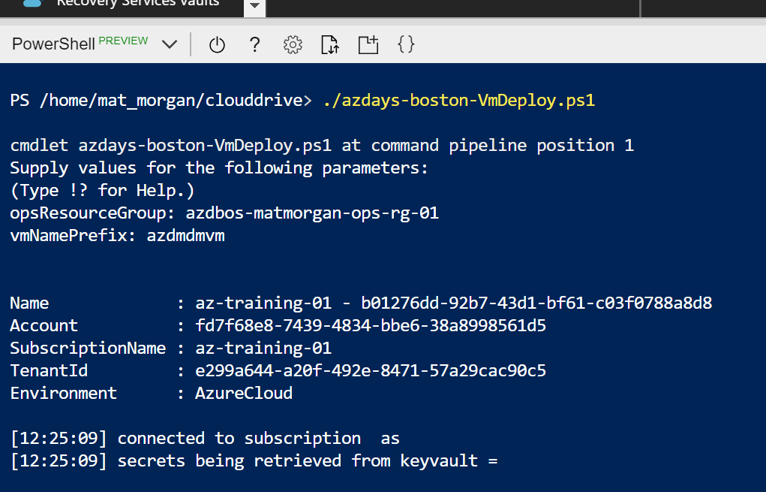

# Step 7 – Explore VM properties with Powershell

## Overview

We will use some example AzureRM Powershell commands to explore how VM resources are deployed in Azure.

## Detailed Steps

1. PS Azure:\> $vms = Get-AzureRmVM -ResourceGroup 'azdbos-matmorgan-vm-rg-01'

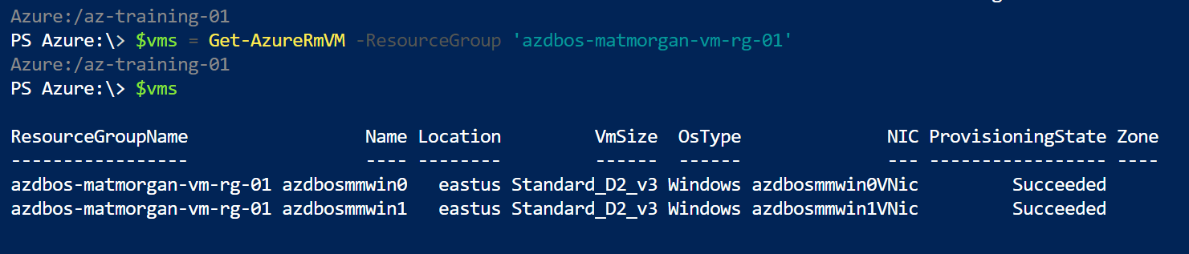

1. PS Azure:\> $vms[0] | get-member

![Azure:/az-training-el 
PS Azure: $vms[e] I get—member 
TypeName: Microsoft.Azure.Commands .Compute.%de1s. PSVirtua1MachineList 
Definition 
Equals 
GetHashCode 
Get Type 
ToPSVirtua1Machine 
ToString 
AvailabilitySetReference 
Diagnosticsprofile 
DisplayHint 
Extensions 
F ul lyQua1i fiedDomainName 
Hardware Profile 
Identity 
InstanceView 
LicenseType 
Locat ion 
Name 
Network Profile 
OSProfi1e 
Plan 
provisioningState 
Req uestld 
ResourceGroupName 
StatusCode 
StorageProfi1e 
Tags 
Type 
vmld 
Zones 
Method 
Method 
Method 
method 
Property 
property 
property 
Property 
Property 
Property 
Property 
Property 
property 
Property 
Property 
Property 
Property 
Property 
Property 
property 
Property 
Property 
Property 
Property 
Property 
Property 
property 
property 
bool Equals (System. Object Obj) 
int GetHashCode() 
type GetType() 
Microsoft .Azure .Conmands.Compute.Mode1s. PSVirtua1Machine ToPSVirtua1Machine() 
string Tostring() 
Microsoft.Azure .Management.Compute .Mode1s .SubResource AvailabilitySetReference {get;set;} 
Microsoft.Azure.Management. Compute.Mode1s.Diagnosticsprofi1e Diagnosticsprofile {get;set;} 
Microsoft. .DispIayHintType DisplayHint {get; set;} 
System.C011ections.Generic.IList[hicrosoft.Azure.Management.Compute.Mode1s.Virtua1MachineExtension] Extensions {get;set;} 
string FullyQua1ifiedDomainName {get; set; 
Microsoft .Azure .Management. Compute.Mode1s .HardwareProfi1e HardwareProfi1e {get;set;} 
string Id {get; set;} 
Microsoft .Azure .Management.Compute .Mode1s .Virtua1MachineIdentity Identity {get;set;} 
Microsoft.Azure Compute.Mode1s.Virtua1MachineInstanceView InstanceView {get;set;} 
string LicenseType {get; set;} 
string Location {get; set;} 
string Name {get;set;} 
Microsoft .Azure .Manageænt.Compute.Mode1s .NetworkProfi1e NetworkProfi1e {get;set;} 
Microsoft.Azure.Management. Compute.Mode1s.OSProfi1e OSProfi1e {get; set;} 
Microsoft .Azure .Management. Compute .Mode1s .P1an Plan {get; set;} 
string provisioningState {get;set;} 
string Requestld {get; set;} 
string ResourceGroupName {get;} 
System.Net. HttpStatusCode StatusCode {get; set; 
Microsoft .Azure .Management. Compute.Mode1s.StorageProfi1e StorageProfi1e {get;set;} 
Systern.C011ections .Generic.IDictionary[string, string] Tags {get; set;} 
string Type {get; set;} 
string Vmld {get; set;} 
System.C011ections .Generic.IList[string] Zones {get; set;} ](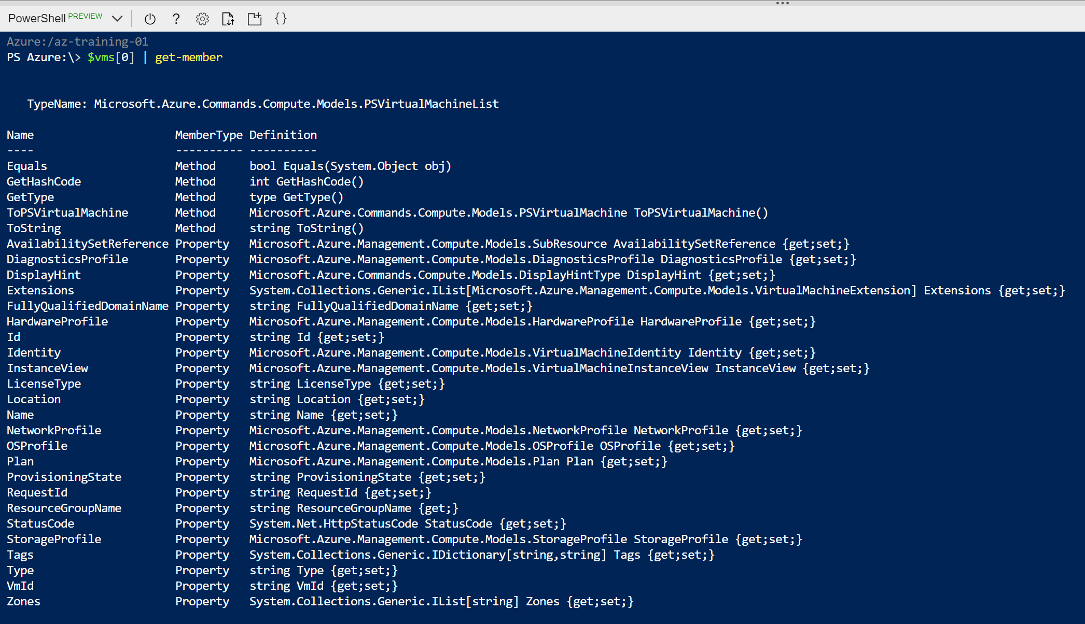)

1. PS Azure:\> $vms[0].StorageProfile

PS Azure:\> $vms[0].StorageProfile.OSDisk

PS Azure:\> $vms[0].StorageProfile.DataDisks

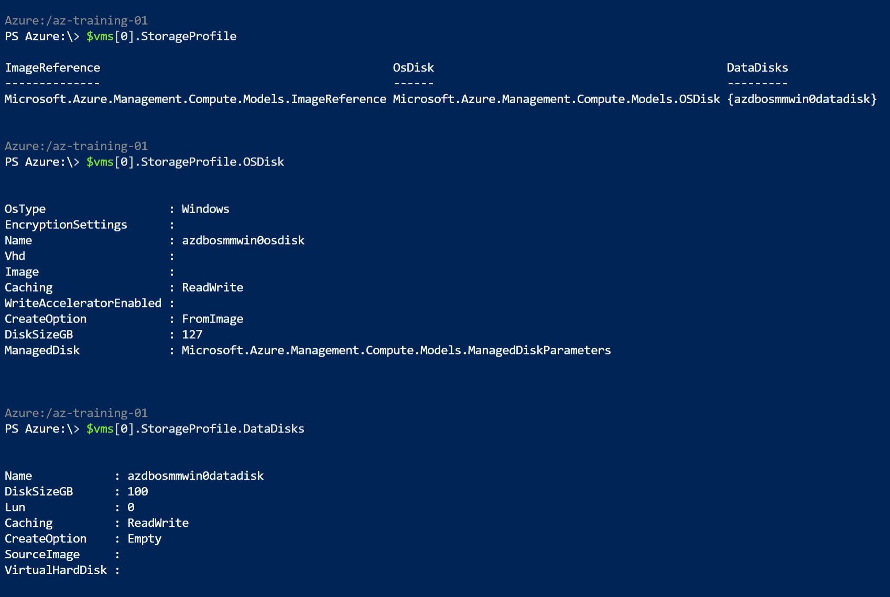

1. <add more commands>

# Step 8 – Configure Backup for VMs

## Overview

Azure Backup service is available as part of the Recovery Vault which was deployed to the Ops resource group. We will configure a backup policy and trigger an initial backup of your VMs.

## Detailed Steps

1. Browse to Backup pane in portal

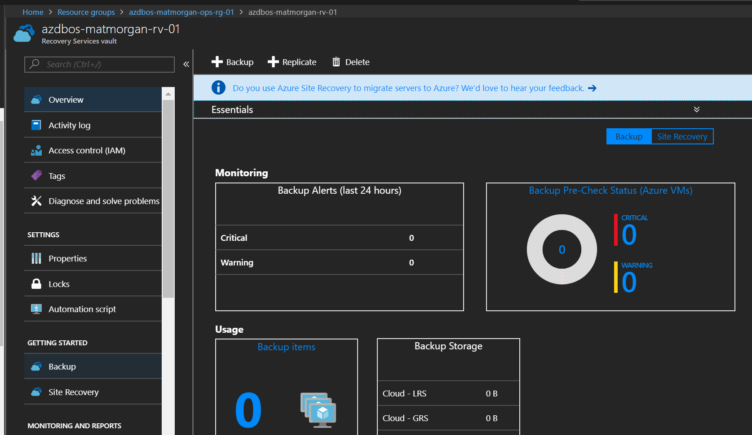

1. Configure a new Backup policy

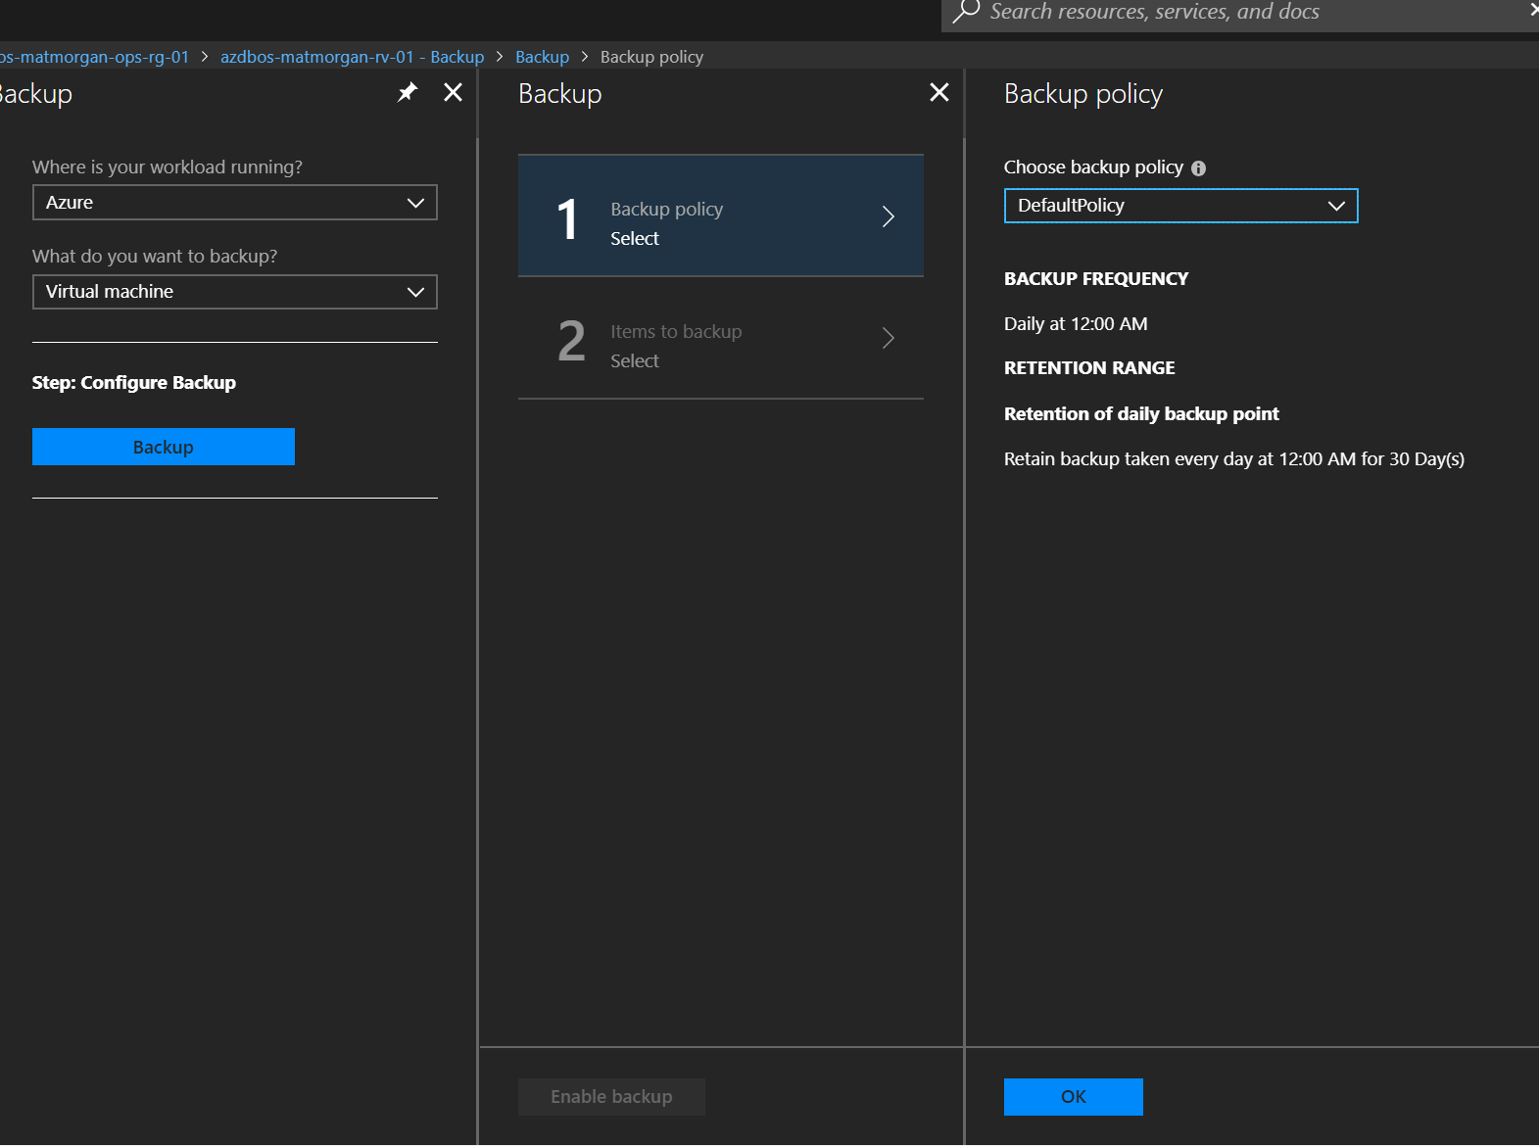

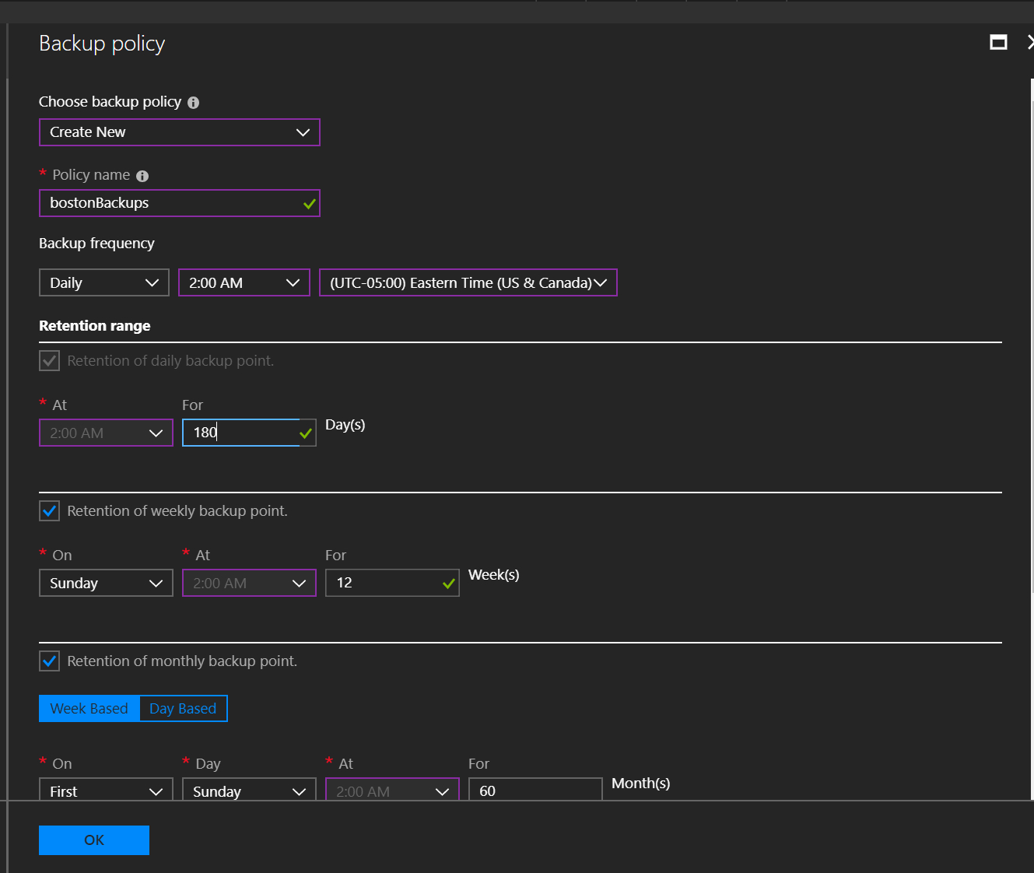

1. Select VMs to backup

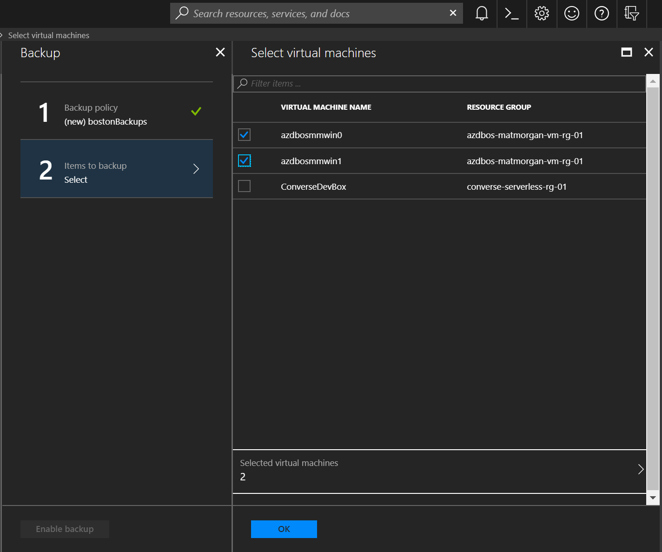

1. Check item backup status and trigger initial backup. Backup will take 60-90 min to complete.

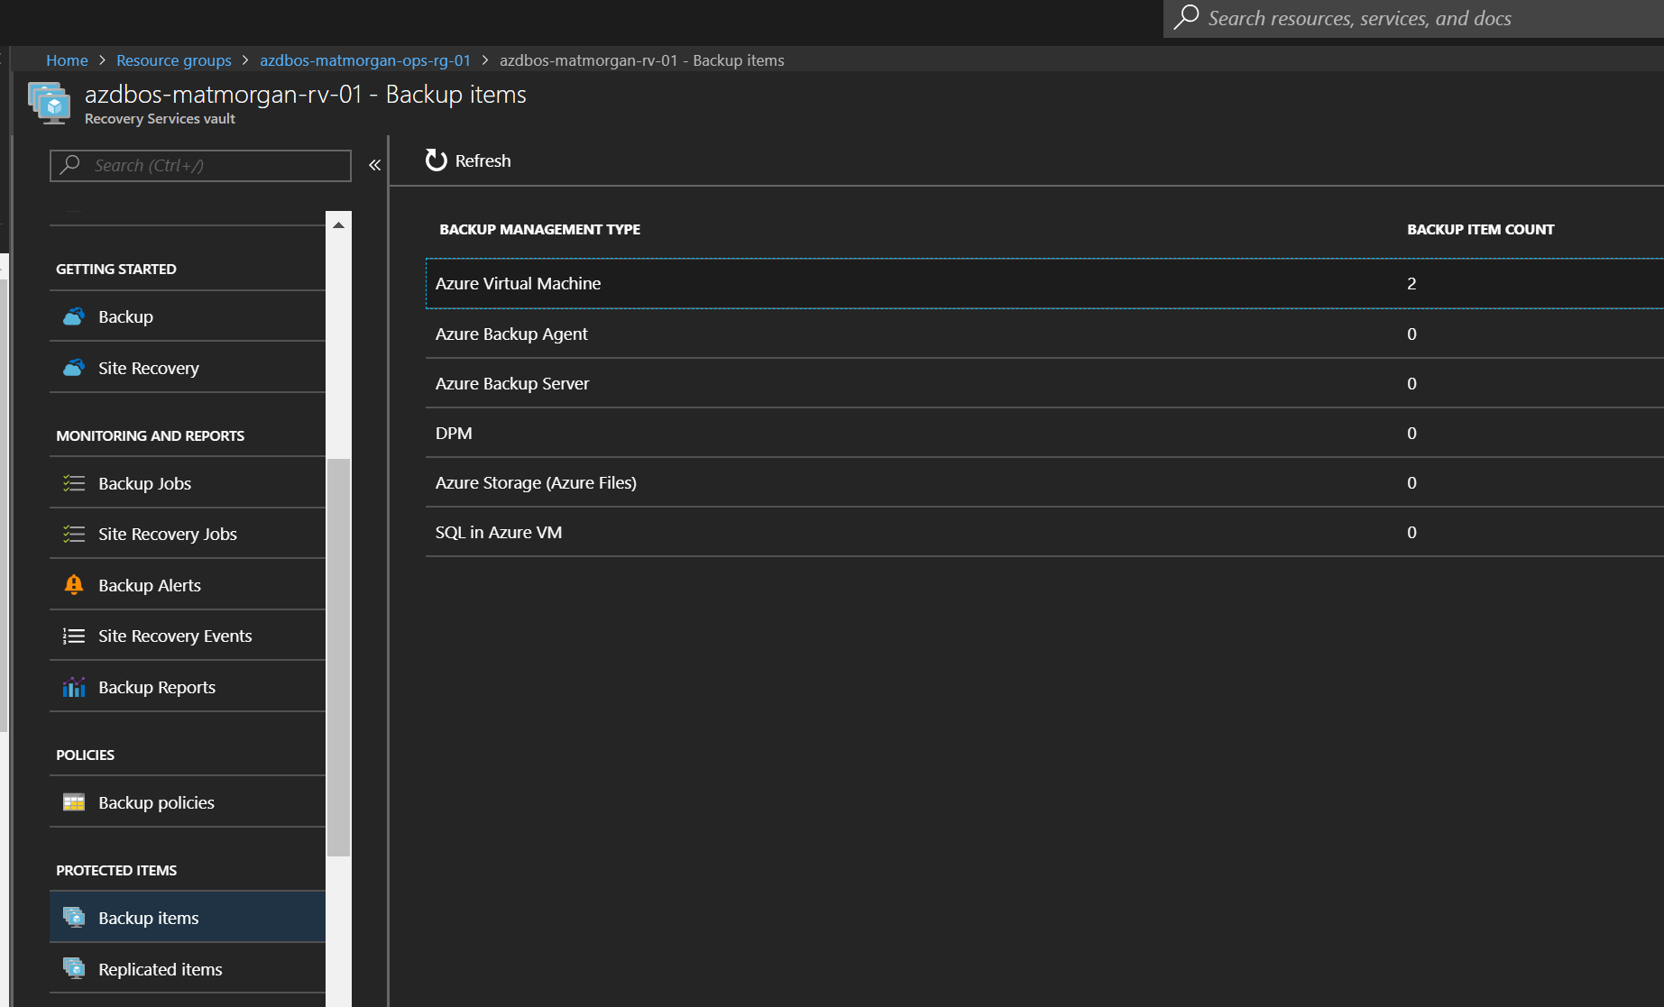

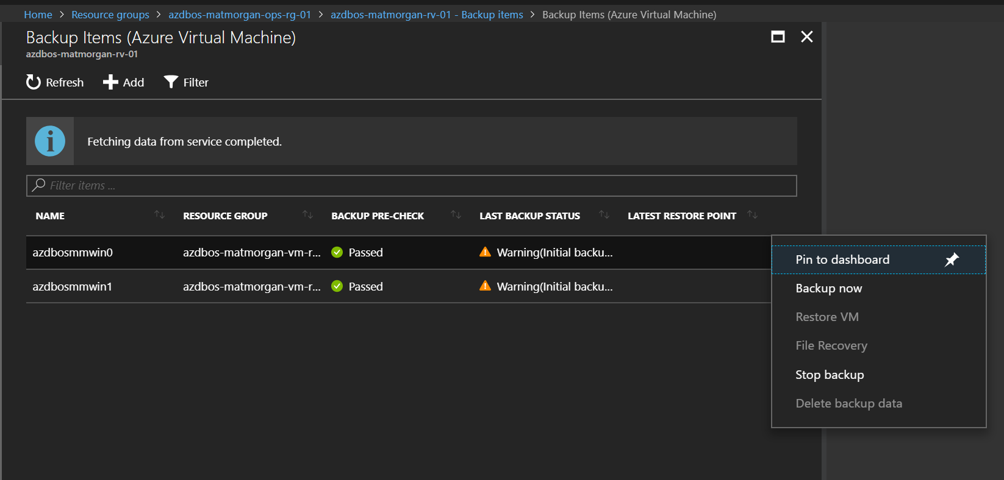

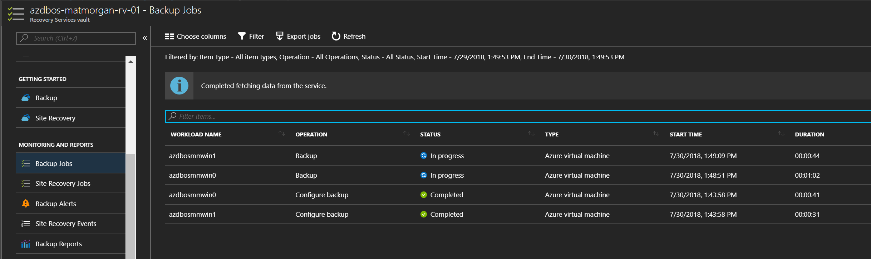

# Step 9 – Create an operations dashboard with Azure Monitor and Log Analytics.

## Overview

For this step we will use both the Azure Monitor service and Log Analytics queries to build and publish a shared dashboard showing VM performance and log data.

## Detailed Steps

1. In the Azure Portal, click the ‘Microsoft Azure’ icon in the top-left to return to the default dashboard. From the default dashboard, click ‘+ New dashboard’ to create a new empty dashboard. Give your dashboard a name.

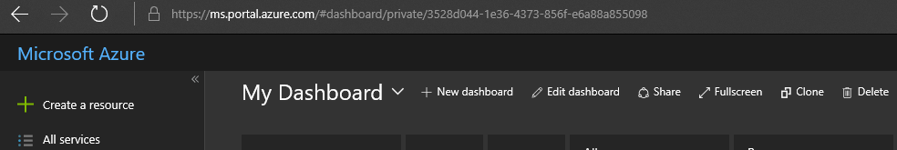

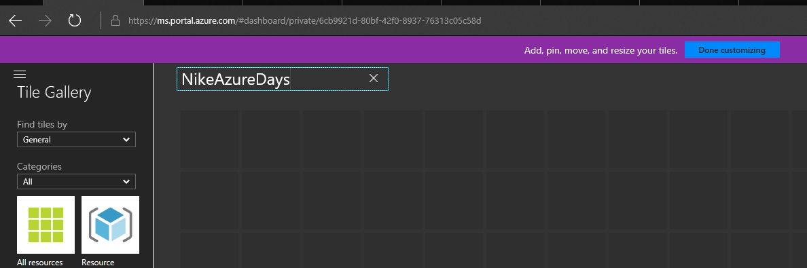

In the ‘Tile Gallery’ on the left, select ‘Find Tiles by’ to ‘Type’ and select ‘Virtual Machines’ from the Type dropdown. In the ‘Resources’ drop down that appears select one of your Virtual Machines. Click and drag the ‘CPU percentage’ tile onto the dashboard and it will appear as a 4x4 tile. Repeat for disk read/write if desired.

Select your other VM from the ‘Resources’ drop down and repeat.   
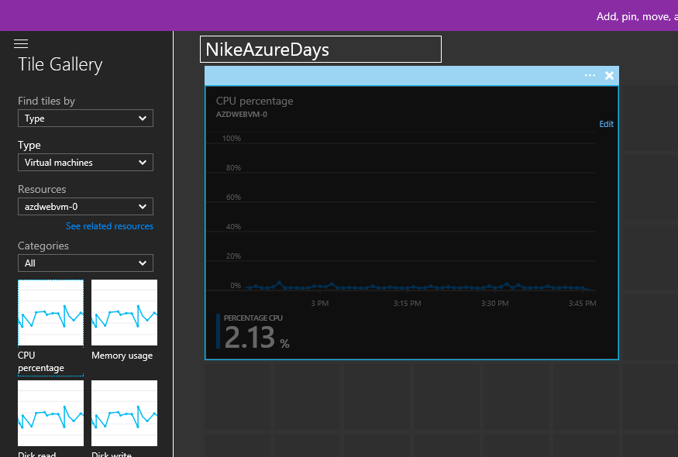

1. Once you have added some tiles to your dashboard, click ‘done customizing’ at the top.

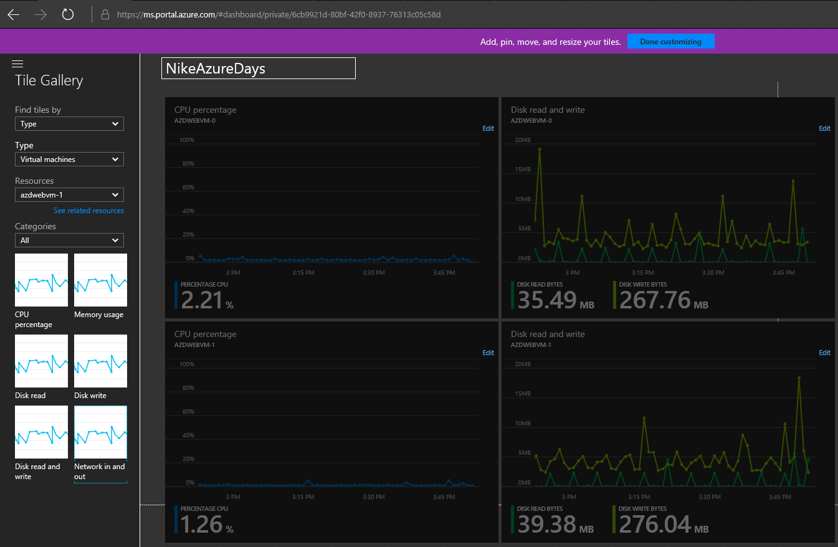

1. From the dashboard page, click ‘Share’ at the top, a sharing blade will open at the right. Uncheck the ‘Publish to the dashboards resource group’ option, and select your Operations resource group from the list and click ‘Publish’.

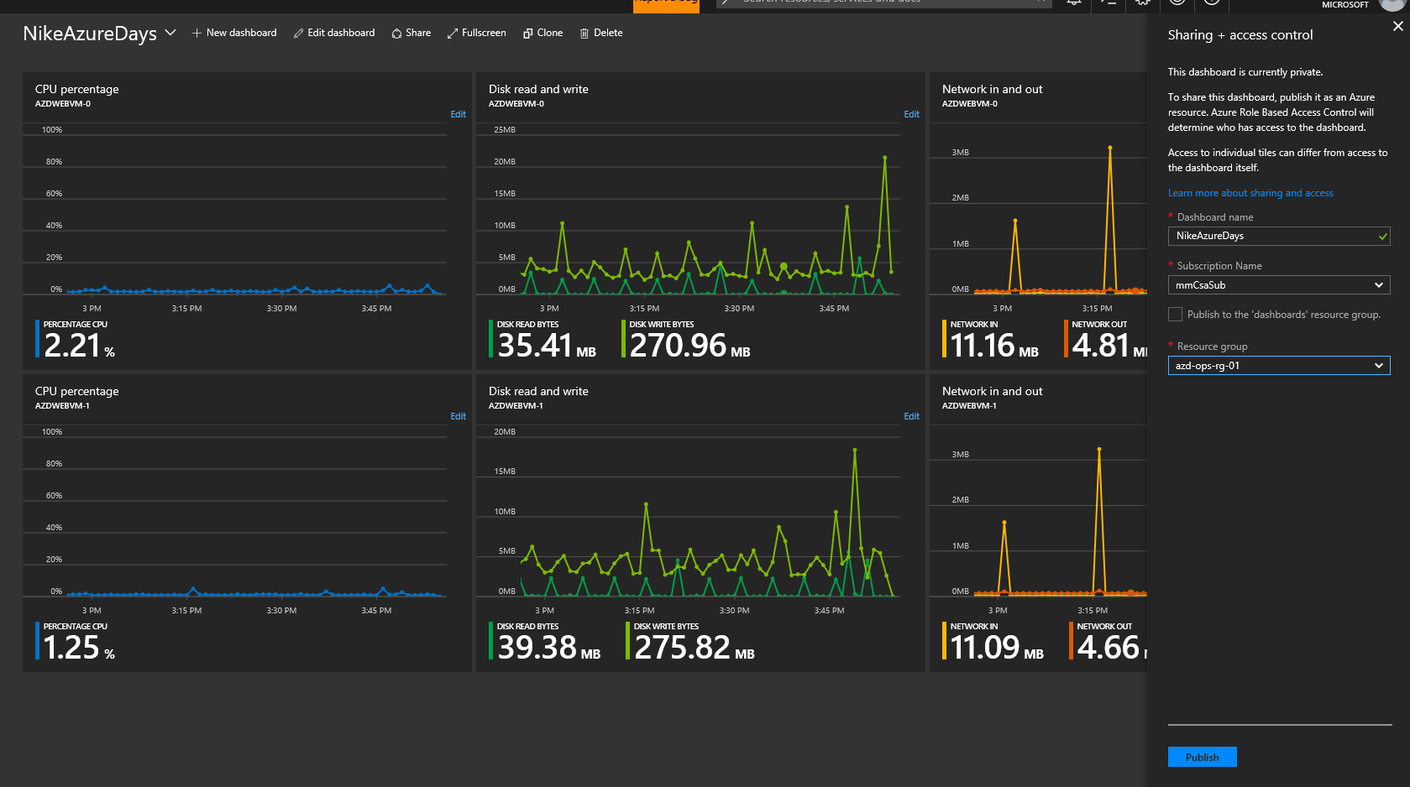

1. Browse to the Log Analytics workspace you created in your Ops resource group and select Log Search to pull up the Log Query page.

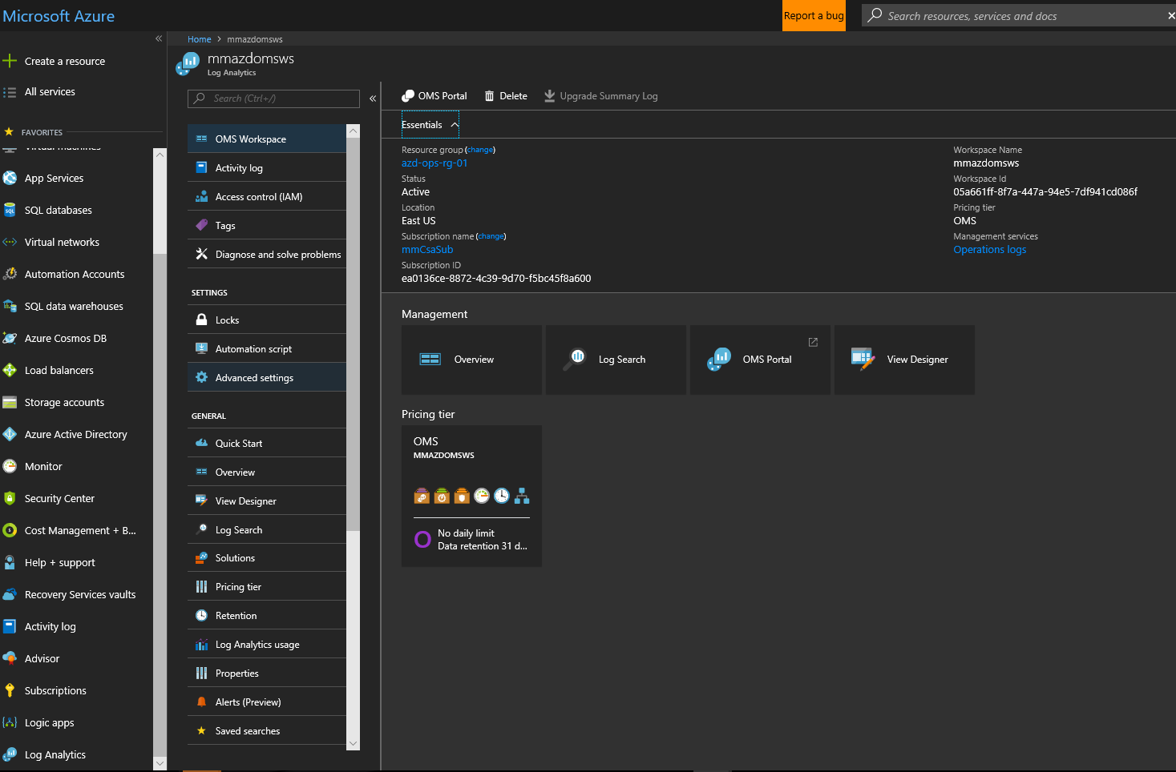

1. While we can run log queries directly from this page, for the purpose of providing a better look at the Log Analytics query functions & data we will use the ‘advanced analytics’ portal for the service. Click ‘Analytics’ at the top of the page to open the **portal.loganalytics.io** site in a new tab. **If you get a ‘403-Forbidden’ error when loading the Advanced Analytics portal, try opening it in an incognito window.

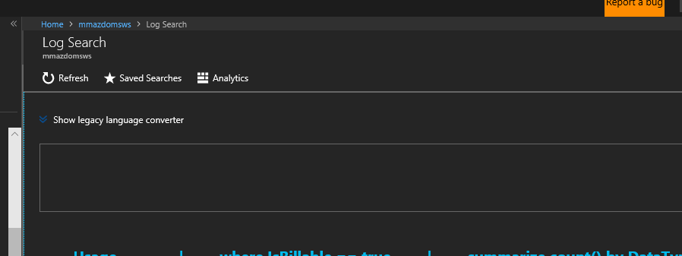

1. From the Log Analytics portal, click ‘+’ to open a new query tab

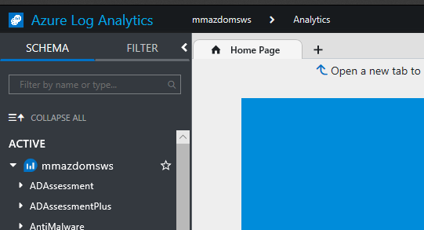

1. In the query window, type ‘Perf’ and hit the ‘Run’ button (or select query text and hit SHIFT + ENTER to run). This will pull all performance log data for your VMs for the time period chosen (default 24 hrs).

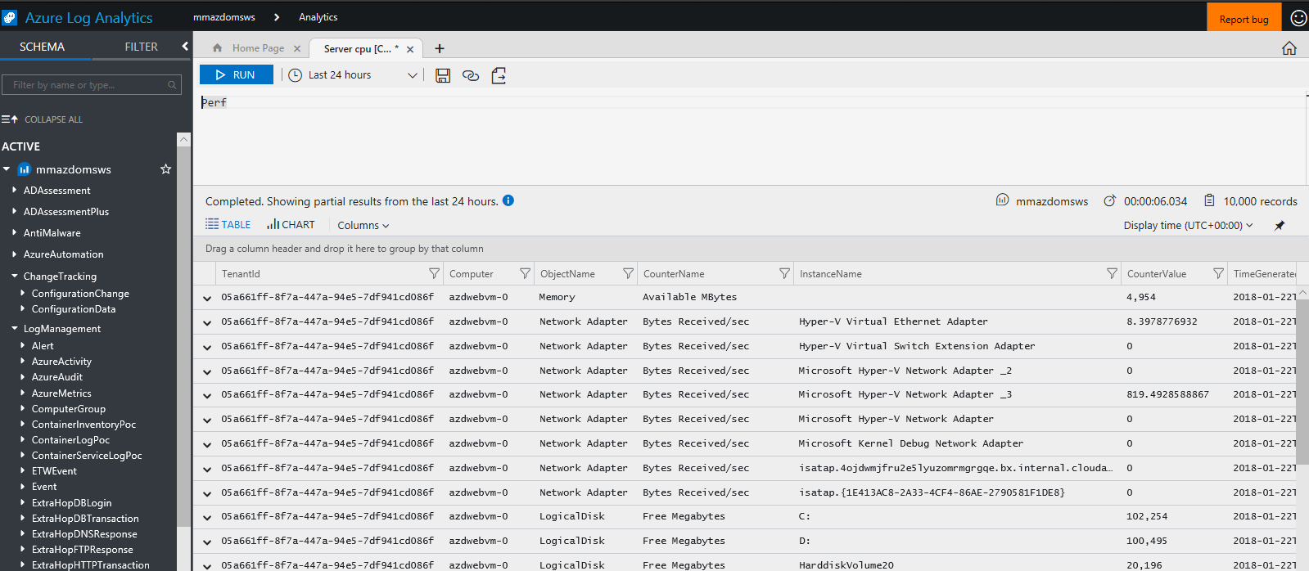

1. Click ‘+’ again to open another query tab. This time paste or type the query below to pull Perf CPU data for all VMs, summarized in 15 min intervals and plotted on a timechart. When you run it, you should get a chart like below.

//Servers CPU

Perf

| where CounterName == "% Processor Time" and ObjectName == "Processor" and InstanceName == "_Total"

| summarize AVGCPU = avg(CounterValue) by bin(TimeGenerated, 15m), Computer

| sort by TimeGenerated desc

| render timechart

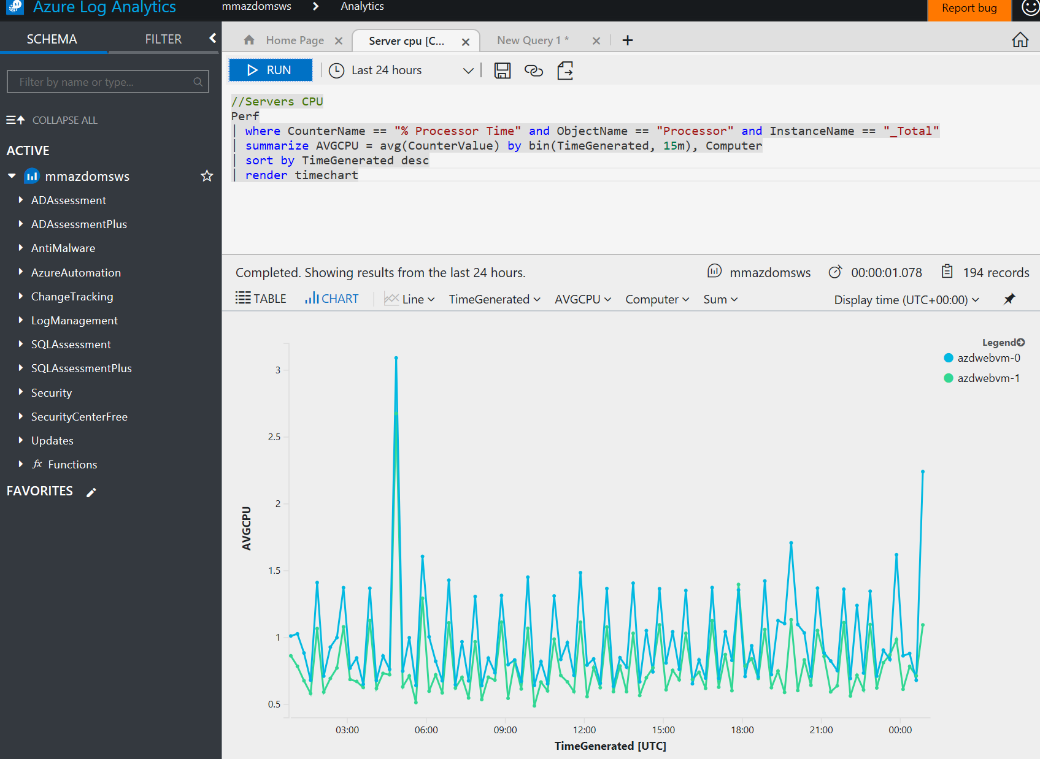

1. Click the ‘pin’ icon at the top-right of the chart to pin the graph to your published dashboard. You should now see this view added to the dashboard.   
   If you need to move the tile, click-hold and drag to edit and then resave/publish. Sometimes you need to take baby-steps when moving tiles.   
   You can click the ‘disk’ icon at the top to save your query into the workspace for later use.

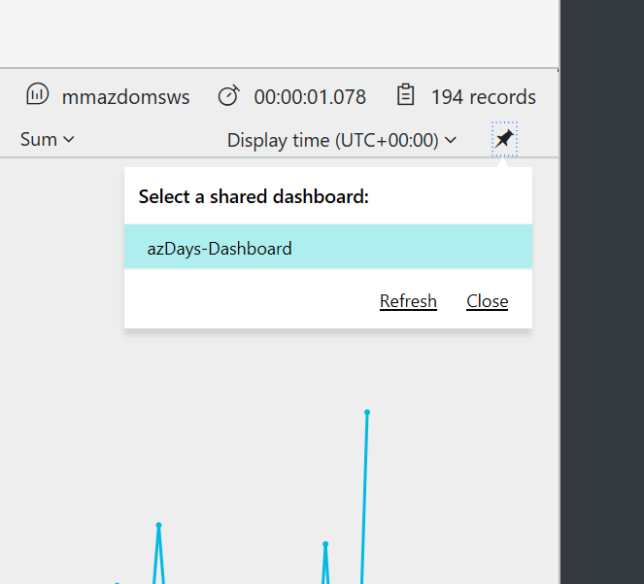

1. Repeat the above steps with these 3 queries to get memory utilization, IIS response time views, Error events, pin the outputs to your dashboard.

Perf

| where CounterName == "% Committed Bytes In Use" and ObjectName == "Memory"

| summarize AVGMEM = avg(CounterValue) by bin(TimeGenerated, 15m), Computer

| sort by TimeGenerated desc

| render timechart

W3CIISLog

| summarize ResponseInMS = avg(TimeTaken) by cIP

| render barchart

let vm1 = Heartbeat | where Computer == "azdwebvm-0";

let vm2 = Heartbeat | where Computer == "azdwebvm-1";

let combinedGroup= union vm1, vm2;

let projectedComputers = combinedGroup | summarize makeset(Computer);

Event

| where Computer in (projectedComputers)

| summarize count(EventLevelName) by Computer, EventLevelName

| render piechart

1. After you’ve pinned a couple of queries to your dashboard, return to the dashboard. To change the title of the tiles you just added, click the ‘…’ icon in top-right corner when hovering over the tile and select ‘Edit Title’. Change the title and subtitle and click ‘update. Then publish your changes again.   
   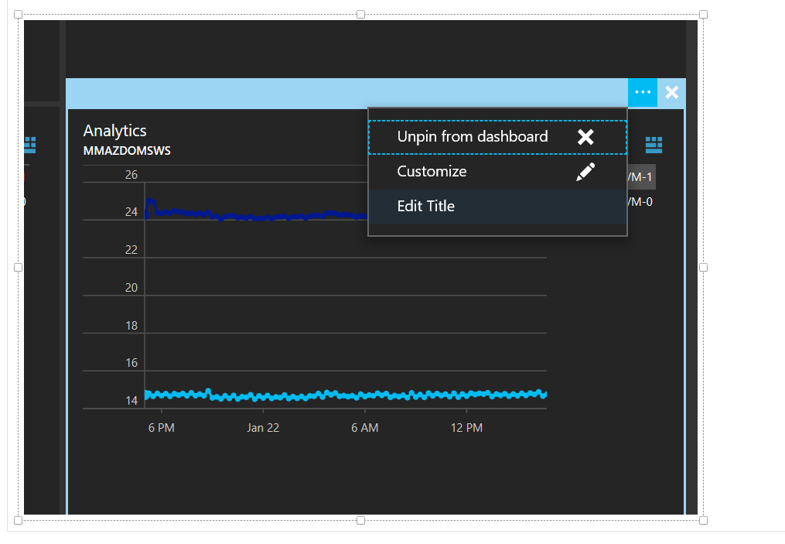
2. From any of the dashboard tiles you pinned from Log Analytics, click the blue ‘Analytics’ icon to return to the query & underlying data.

## Extra Credit

Visit the language query reference here: <https://docs.loganalytics.io/docs/Language-Reference>

Produce more queries and a make an even better dashboard!

# Step 10 (optional) – Deploy Azure Container Registry for container images

## Overview

We will be creating Docker container images from our Windows servers after they have been configured. While the deployment script runs, we will create an Azure Container Registry to be able to store Docker images.

## Detailed Steps

1. Create a new Container Registry in the Ops resource group, Basic SKU with -EnableAdminUser flag so we can retrieve credentials later. Change the value for -Name to whatever unique alphanumeric name you wish.  
     
   $registry = New-AzureRmContainerRegistry -Name "azdayscontreg" -ResourceGroupName $OpsResourceGroup -Sku Basic -EnableAdminUser
2. Retrieve the registry credential & copy username + password to notepad for later:  
   .   
   $dockerCredential = Get-AzureRmContainerRegistryCredential -ResourceGroupName $OpsResourceGroup -Name $registry.Name   
     
   $dockerCredential

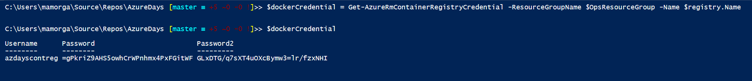

1. Once you have copied the user/password, we will create a secure credential object we can use to redeploy images from the Container Registry with in a later step.   
     
   $dockerSecurePass = ($dockerCredential.Password | ConvertTo-SecureString -AsPlainText -Force)

$dockerCredential = New-Object System.Management.Automation.PSCredential ($dockerCredential.Username, $dockerSecurePass)

# Step 11 (optional) – Create Docker container from website and push to Azure Container Registry.

## Overview

Inception! For this step we will take advantage of Windows Containers in Server 2016 and build a Server Core + IIS container running our site from inside our VM. We will then push the container image to our Azure Container Registry.

## Detailed Steps

1. From an RDP session you either of your VMs, open a Powershell window.

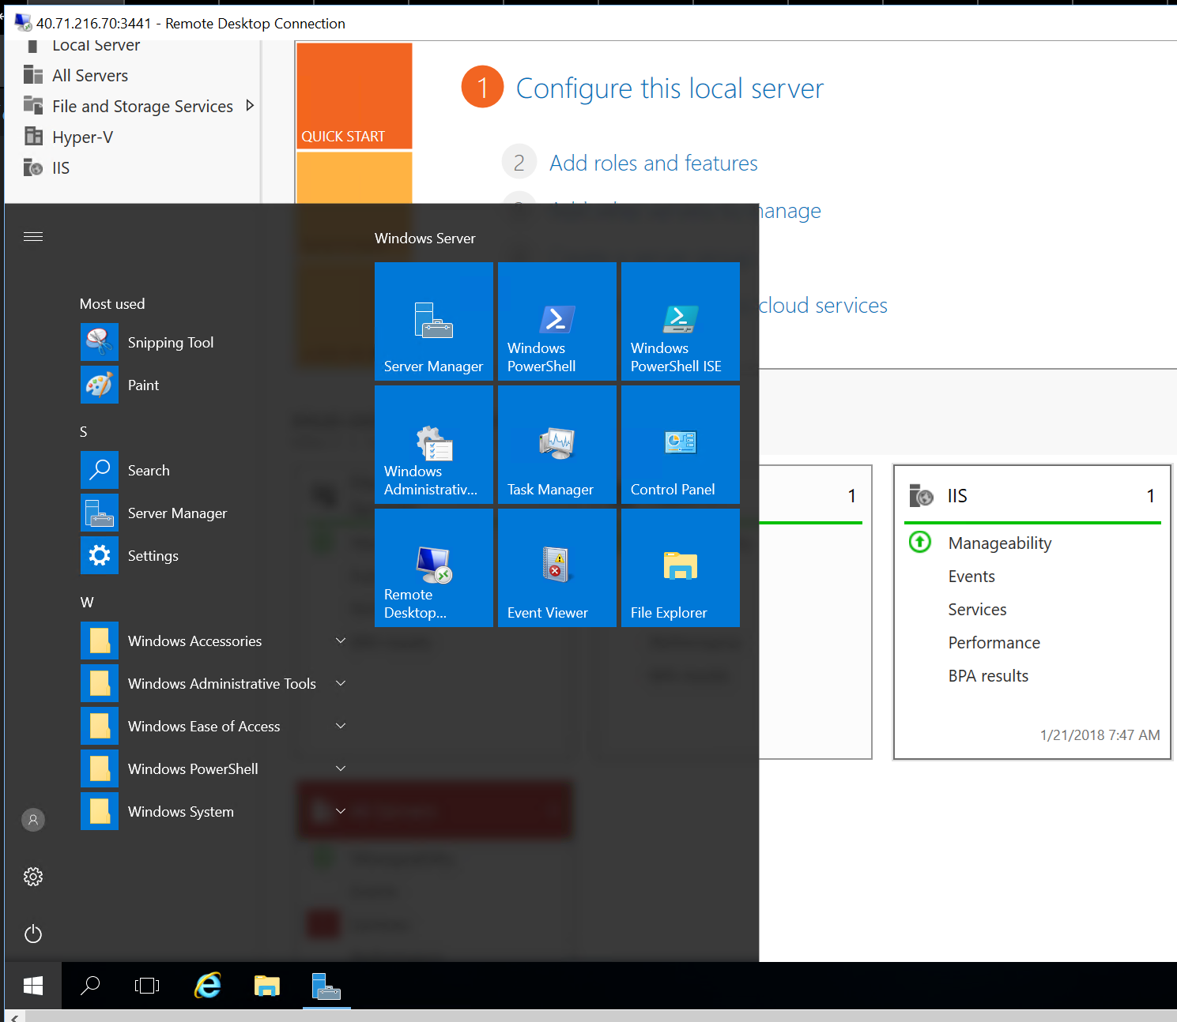

1. Create a new directory called ‘docker’ in your profile, cd to it.

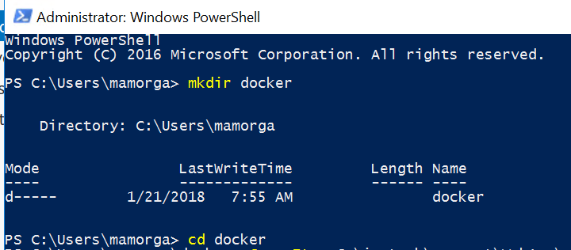

1. Copy the contents if the IIS website at C:\inetpub\wwwroot\WebApp\website into your docker directory.

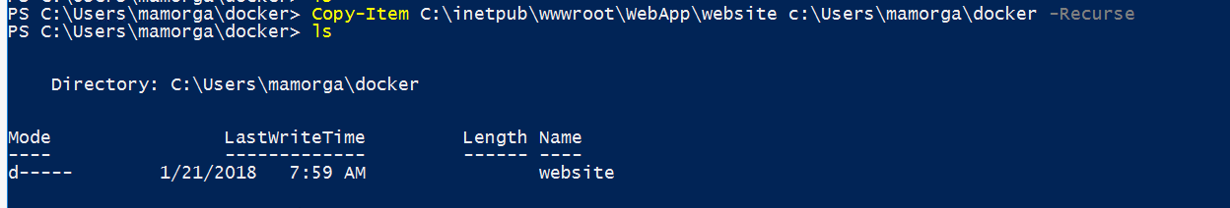

1. From Powershell, type ‘docker pull microsoft/iis’ to pull the Server Core + IIS container from Docker Hub. It will take a few minutes to pull & extract.

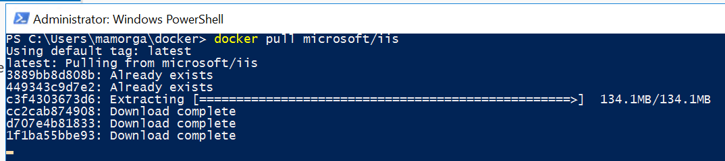

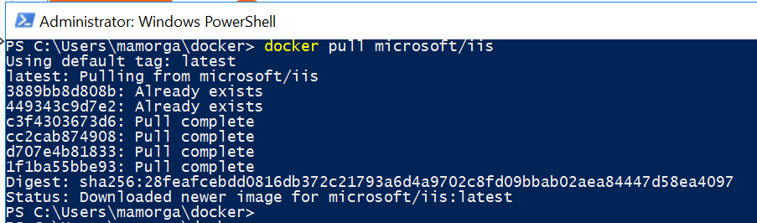

1. Type ‘notepad Dockerfile’ to create a new text file. Either copy/paste or enter the text as shown to create a Dockerfile that uses PS to configure the IIS site in the container, then adds the content from the docker\website directory to the container image. Note the first line designates **`** as the escape character instead of default **\** to avoid issues with Windows file paths. When complete, ‘Save As’ without any file extension with name as “Dockerfile” **include quotations**

# escape=`

FROM microsoft/iis

RUN mkdir C:\site

RUN powershell -NoProfile -Command `

Import-module IISAdministration; `

New-IISSite -Name "Site" -PhysicalPath C:\site -BindingInformation "*:8000:"

EXPOSE 8000

ADD \website /site

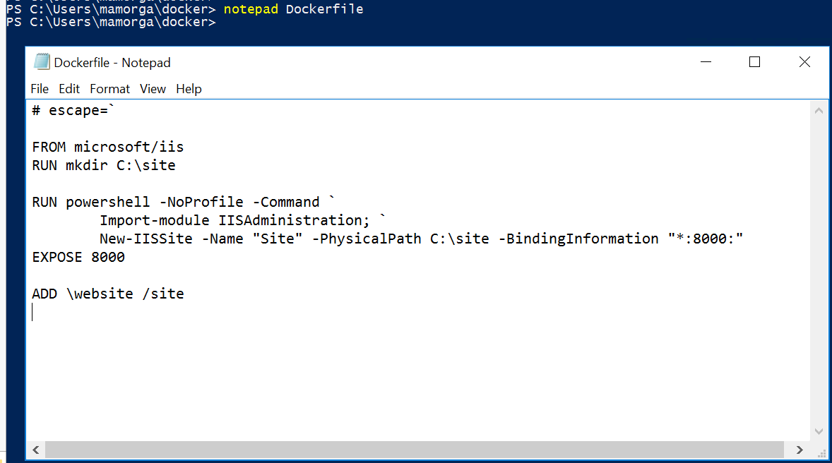

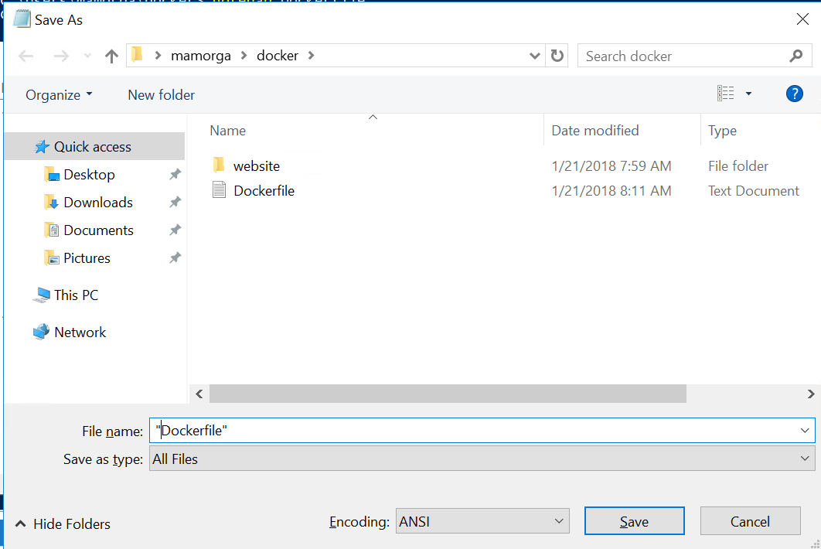

1. Type ‘**docker build -t iis-site .**’ (including period) to build the image from Dockerfile.

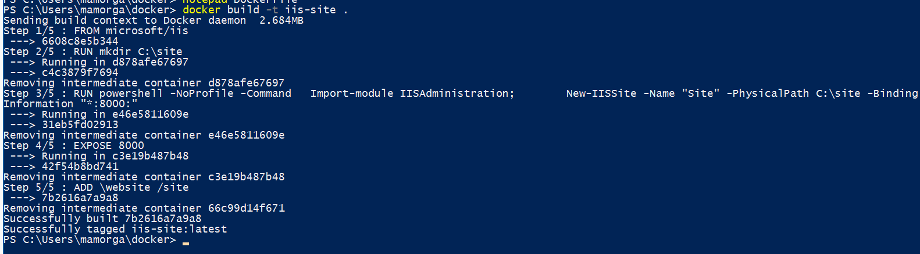

1. Type ‘**docker image ls**’ to view your image

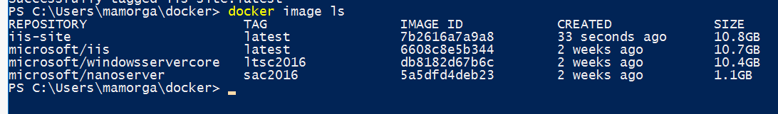

1. Type ‘**docker run -d -p 8000:8000 --name azdays-site iis-site**’ to run the container with port 8000 exposed. Type ‘docker ps -a’ to see the container state.

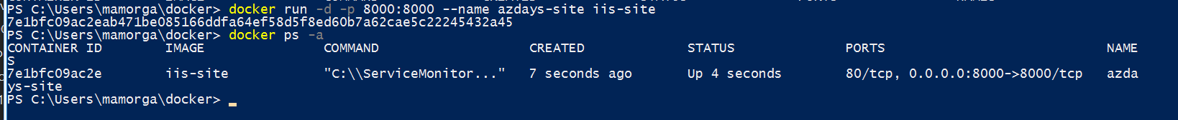

1. Type ‘**docker inspect -f "{{ .NetworkSettings.Networks.nat.IPAddress }}" azdays-site**’ to retrieve the IP address exposed for your container.



1. Open Internet Explorer from inside your RDP session. Accept the security prompt and browse to ‘**http://<your-container-ip>:8000**’ . You’ll have to click ‘Add’ 2x to approve the security zone prompt, then should see your site.

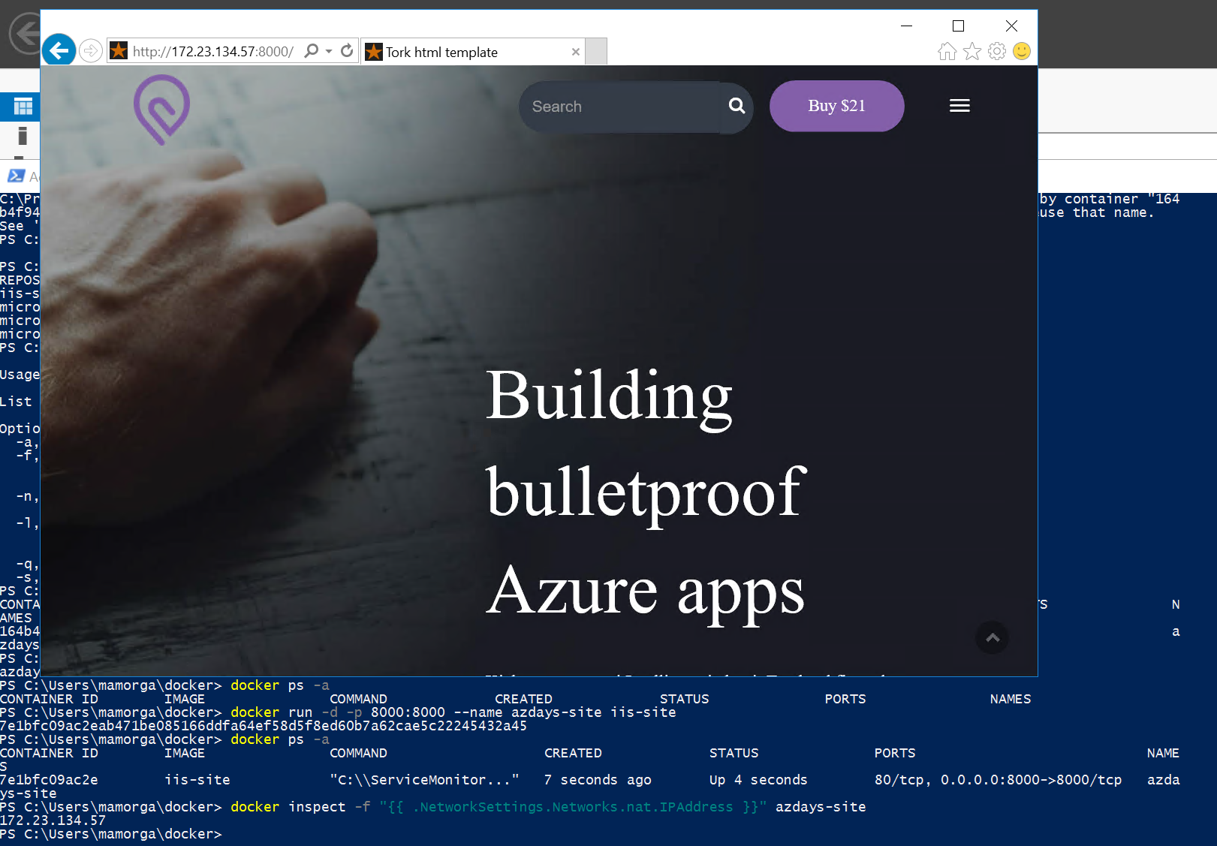

1. Find the Username and Password for the Azure Container Registry you saved earlier. The username will be the same as your ACR name.
2. Type ‘**docker tag iis-site <your-acr-username>.azurecr.io/iis-site:v1**’ to tab the image to push to the Registry.
3. Type ‘**docker login <your-acr-username>.azurecr.io -u <your-acr-username> -p <your-acr-password>**’ to login to ACR.
4. Type ‘**docker push <your-acr-username>..azurecr.io/iis-site:v1**’ to push your image to the Registry.

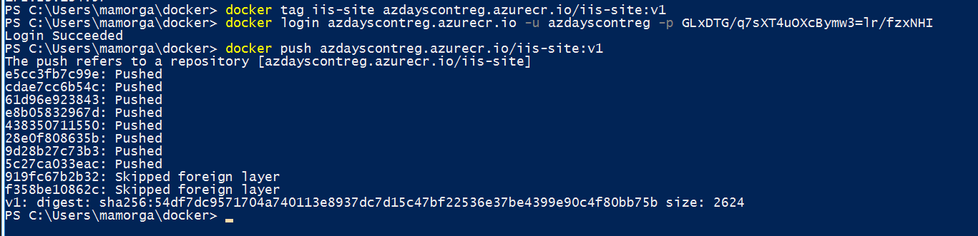

# Step 12 (optional) – Create an Azure Container Instance from image in Registry.

## Overview

Now just for fun, we will take our container image and redeploy it as an Azure Container Instance. Container Instances provide a fast easy way to deploy images in a PaaS service with no infrastructure for development.

## Detailed Steps

1. Run the following to create a new Container Group in the VM resource group using the image we just pushed. We will expose port 8000 on a public IP and use the secure credential object we created earlier to connect to the Registry.   
     
   $aci = New-AzureRmContainerGroup `

-ResourceGroupName $vmResourceGroup `

-Name azd-site `

-Image <your-acr-name>.azurecr.io/iis-site:v1 `

-OsType Windows `

-IpAddressType Public `

-Port 8000 `

-RegistryCredential $dockerCredential

1. Type ‘$aci’ to check status after deploying. In a couple of minutes, you should see status as ‘Running’. Note the IP address shown.   
   **note – the status may show ‘pending’ in powershell response for several minutes after the container is actually available, worth testing the site to see.

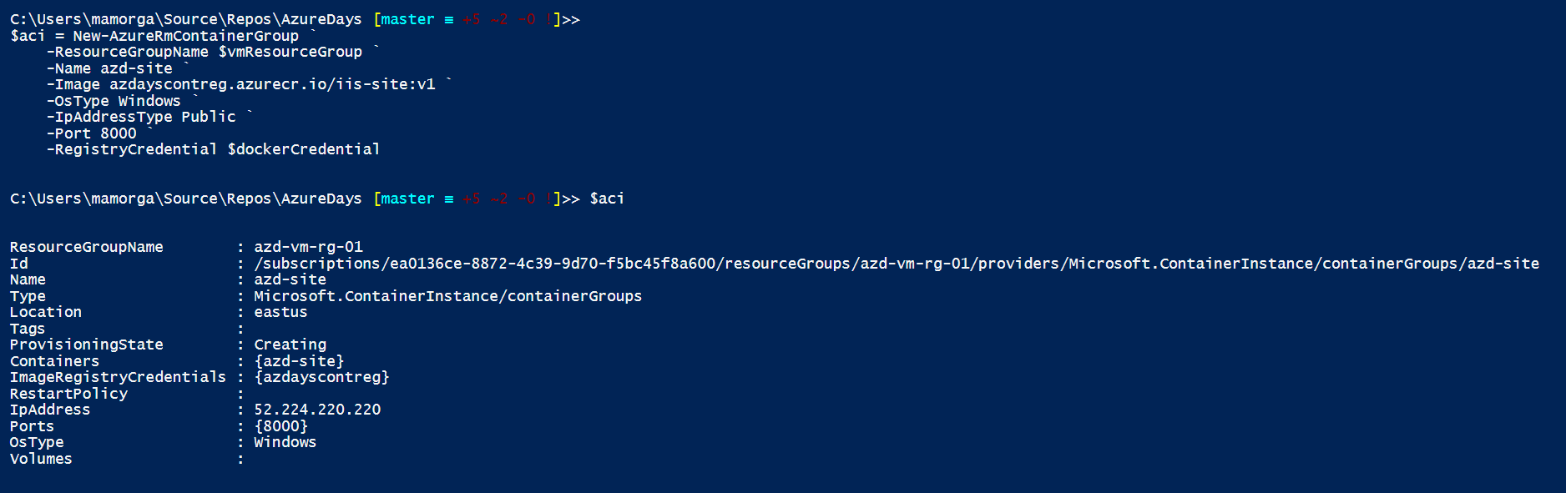

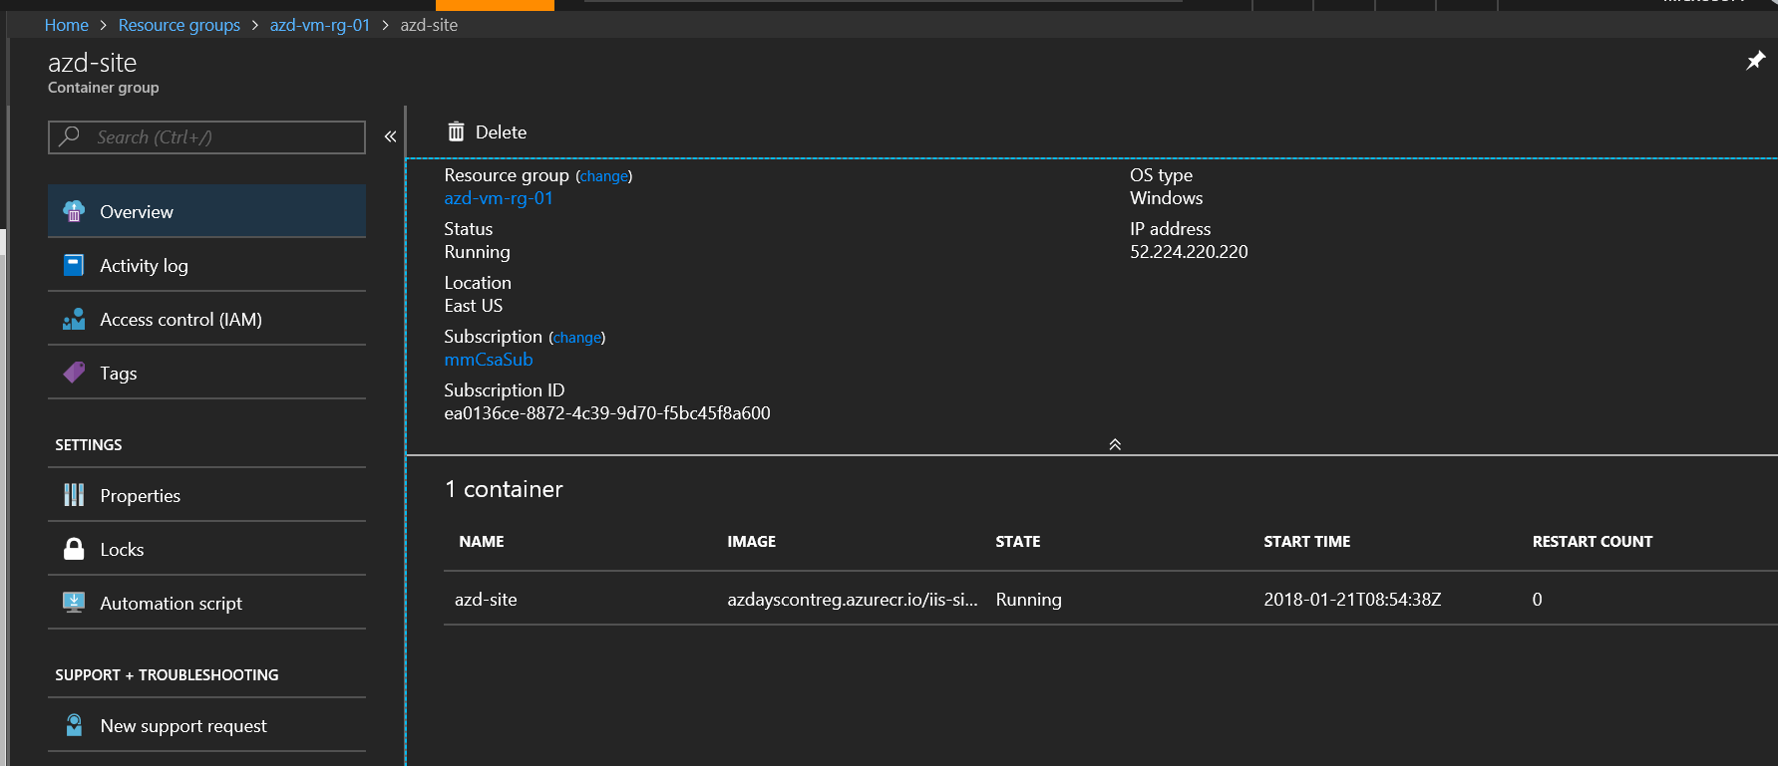

1. Try to connect to your Container Instance from a browser at ‘http://<aci-ip-address>:8000’

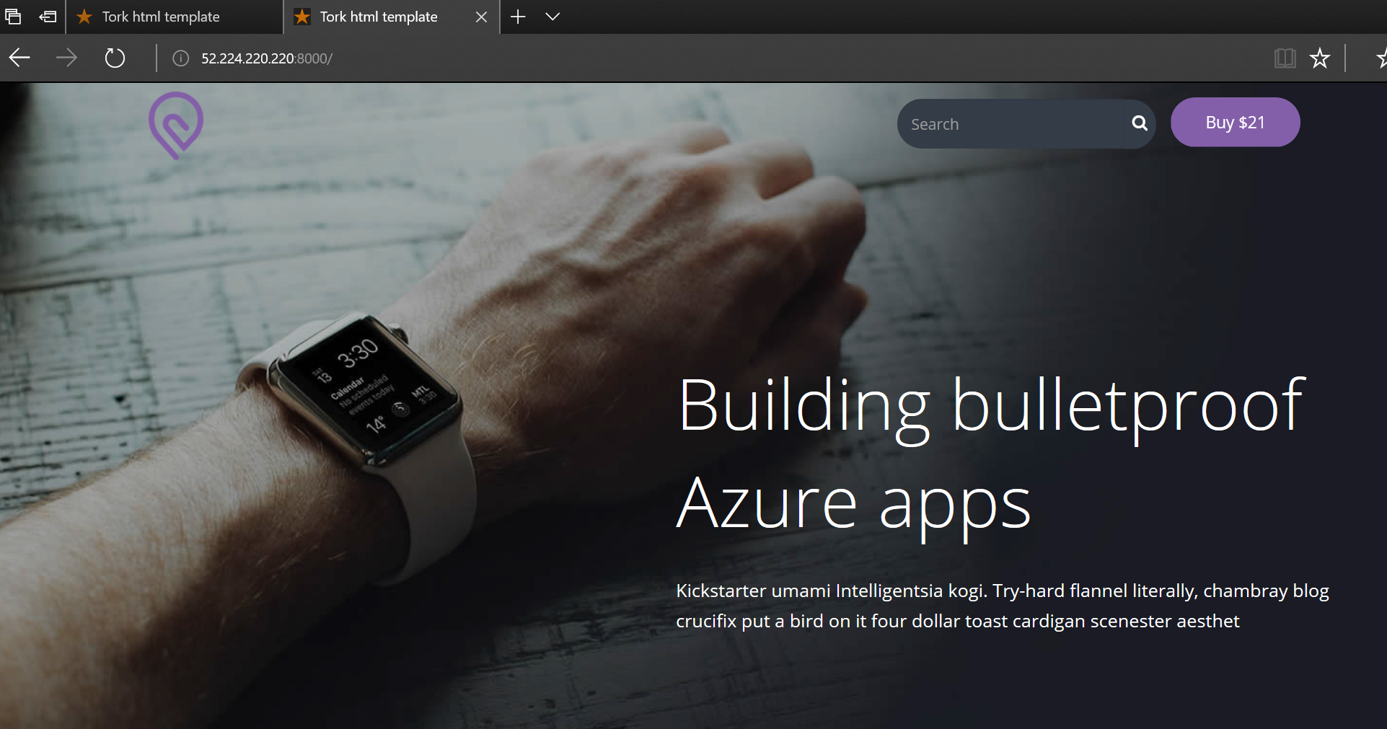

# Step 13 – Clean up

## Overview

To clean up from the workshop, delete each of the 3 resource groups you created in reverse order: 1st VM resource group, 2nd VNET resource group, 3rd Ops resource group.

## Detailed Steps

Browse to each resource group landing blade. Click Delete and type the name of the resource group to confirm. You can delete all 3 without waiting for completion of the previous ones.